**ID: bvarshsp**

**Name: Varsha SP**

**Day 5 – 28th May 2025**

**Photocopies are below this copy pasted command lines. Had issue with taking screenshots from VM.**

**Below are the command lines that I used entire day today to practice and to complete tasks on ubuntu VMware.**

ubuntu@ubuntu:~$ mkdir linuxlearning  
ubuntu@ubuntu:~$ cd linuxlearning/  
ubuntu@ubuntu:~/linuxlearning$ touch linuxfile  
ubuntu@ubuntu:~/linuxlearning$ mkdir dummy  
ubuntu@ubuntu:~/linuxlearning$ cd dummy/  
ubuntu@ubuntu:~/linuxlearning/dummy$ rm dummy  
rm: cannot remove 'dummy': No such file or directory  
ubuntu@ubuntu:~/linuxlearning/dummy$ rmdir  
rmdir: missing operand  
Try 'rmdir --help' for more information.  
ubuntu@ubuntu:~/linuxlearning/dummy$ cd ..  
ubuntu@ubuntu:~/linuxlearning$ cd ..  
ubuntu@ubuntu:~$ mkdir dummy  
ubuntu@ubuntu:~$ rm dummy  
rm: cannot remove 'dummy': Is a directory  
ubuntu@ubuntu:~$ rmdir  
rmdir: missing operand  
Try 'rmdir --help' for more information.  
ubuntu@ubuntu:~$ cd linuxlearning/  
ubuntu@ubuntu:~/linuxlearning$ touch testfile  
ubuntu@ubuntu:~/linuxlearning$ nano testfile  
ubuntu@ubuntu:~/linuxlearning$ ./testfile  
bash: ./testfile: Permission denied  
ubuntu@ubuntu:~/linuxlearning$ chmod a+x testfile  
ubuntu@ubuntu:~/linuxlearning$ ls -l  
total 8  
drwxrwxr-x 2 ubuntu ubuntu 4096 May 28 10:42 dummy  
-rw-rw-r-- 1 ubuntu ubuntu    0 May 28 10:39 linuxfile  
-rwxrwxr-x 1 ubuntu ubuntu   65 May 28 10:51 testfile  
ubuntu@ubuntu:~/linuxlearning$ ls -ltr  
total 8  
-rw-rw-r-- 1 ubuntu ubuntu    0 May 28 10:39 linuxfile  
drwxrwxr-x 2 ubuntu ubuntu 4096 May 28 10:42 dummy  
-rwxrwxr-x 1 ubuntu ubuntu   65 May 28 10:51 testfile  
ubuntu@ubuntu:~/linuxlearning$ ./testfile  
This is my linux practise  
ubuntu@ubuntu:~/linuxlearning$ ^C  
ubuntu@ubuntu:~/linuxlearning$ touch TestFile1  
ubuntu@ubuntu:~/linuxlearning$ nano TestFile1  
ubuntu@ubuntu:~/linuxlearning$ chmod a+x TestFile1  
ubuntu@ubuntu:~/linuxlearning$ ./TestFile1  
Hello all! How is atlas training going on?  
ubuntu@ubuntu:~/linuxlearning$ touch TestFile2  
ubuntu@ubuntu:~/linuxlearning$ touch TestFile3  
ubuntu@ubuntu:~/linuxlearning$ touch TestFile4  
ubuntu@ubuntu:~/linuxlearning$ touch TestFile5  
ubuntu@ubuntu:~/linuxlearning$ touch TestFile6  
ubuntu@ubuntu:~/linuxlearning$ ^C  
ubuntu@ubuntu:~/linuxlearning$ pwd  
/home/ubuntu/linuxlearning  
ubuntu@ubuntu:~/linuxlearning$ ls  
dummy  linuxfile  testfile  TestFile1  TestFile2  TestFile3  TestFile4  TestFile5  TestFile6  
ubuntu@ubuntu:~/linuxlearning$ ls -l  
total 12  
drwxrwxr-x 2 ubuntu ubuntu 4096 May 28 10:42 dummy  
-rw-rw-r-- 1 ubuntu ubuntu    0 May 28 10:39 linuxfile  
-rwxrwxr-x 1 ubuntu ubuntu   65 May 28 10:51 testfile  
-rwxrwxr-x 1 ubuntu ubuntu   48 May 28 11:13 TestFile1  
-rw-rw-r-- 1 ubuntu ubuntu    0 May 28 11:13 TestFile2  
-rw-rw-r-- 1 ubuntu ubuntu    0 May 28 11:14 TestFile3  
-rw-rw-r-- 1 ubuntu ubuntu    0 May 28 11:14 TestFile4  
-rw-rw-r-- 1 ubuntu ubuntu    0 May 28 11:14 TestFile5  
-rw-rw-r-- 1 ubuntu ubuntu    0 May 28 11:14 TestFile6  
ubuntu@ubuntu:~/linuxlearning$ ls -ltr  
total 12  
-rw-rw-r-- 1 ubuntu ubuntu    0 May 28 10:39 linuxfile  
drwxrwxr-x 2 ubuntu ubuntu 4096 May 28 10:42 dummy  
-rwxrwxr-x 1 ubuntu ubuntu   65 May 28 10:51 testfile  
-rwxrwxr-x 1 ubuntu ubuntu   48 May 28 11:13 TestFile1  
-rw-rw-r-- 1 ubuntu ubuntu    0 May 28 11:13 TestFile2  
-rw-rw-r-- 1 ubuntu ubuntu    0 May 28 11:14 TestFile3  
-rw-rw-r-- 1 ubuntu ubuntu    0 May 28 11:14 TestFile4  
-rw-rw-r-- 1 ubuntu ubuntu    0 May 28 11:14 TestFile5  
-rw-rw-r-- 1 ubuntu ubuntu    0 May 28 11:14 TestFile6  
ubuntu@ubuntu:~/linuxlearning$ cd ..  
ubuntu@ubuntu:~$ mkdir linuxfiles  
ubuntu@ubuntu:~$ cp /linuxlearning/TestFile[1-6] /linuxfiles  
cp: cannot stat '/linuxlearning/TestFile[1-6]': No such file or directory  
ubuntu@ubuntu:~$ cp linuxlearning/TestFile[1-6] /linuxfiles  
cp: target '/linuxfiles' is not a directory  
ubuntu@ubuntu:~$ cp /home/ubuntu/linuxlearning/TestFile[1-6] /home/ubuntu/linuxfiles/  
ubuntu@ubuntu:~$ cd linuslearning  
bash: cd: linuslearning: No such file or directory  
ubuntu@ubuntu:~$ cd linuxlearning  
ubuntu@ubuntu:~/linuxlearning$ ls  
dummy  linuxfile  testfile  TestFile1  TestFile2  TestFile3  TestFile4  TestFile5  TestFile6  
ubuntu@ubuntu:~/linuxlearning$ cd linuxfiles/  
bash: cd: linuxfiles/: No such file or directory  
ubuntu@ubuntu:~/linuxlearning$ cd..  
cd..: command not found  
ubuntu@ubuntu:~/linuxlearning$ cd ..  
ubuntu@ubuntu:~$ cd linuxfiles  
ubuntu@ubuntu:~/linuxfiles$ ls  
TestFile1  TestFile2  TestFile3  TestFile4  TestFile5  TestFile6  
ubuntu@ubuntu:~/linuxfiles$ cd linuxlearning/  
bash: cd: linuxlearning/: No such file or directory  
ubuntu@ubuntu:~/linuxfiles$ cd ..  
ubuntu@ubuntu:~$ cd linuxlearning/  
ubuntu@ubuntu:~/linuxlearning$ mv TestFile[1-6] /linuxfiles/  
mv: target '/linuxfiles/' is not a directory  
ubuntu@ubuntu:~/linuxlearning$ cp /home/ubuntu/linuxlearning/TestFile[1-6] /home/ubuntu/linuxfiles/  
ubuntu@ubuntu:~/linuxlearning$ cd ..  
ubuntu@ubuntu:~$ mv /home/ubuntu/linuxlearning/TestFile[1-6] /home/ubuntu/linuxfiles/  
ubuntu@ubuntu:~$ cd linuxlearning/  
ubuntu@ubuntu:~/linuxlearning$ ls  
dummy  linuxfile  testfile  
ubuntu@ubuntu:~/linuxlearning$ rm dummy  
rm: cannot remove 'dummy': Is a directory  
ubuntu@ubuntu:~/linuxlearning$ rm linuxlearning/dummy  
rm: cannot remove 'linuxlearning/dummy': No such file or directory  
ubuntu@ubuntu:~/linuxlearning$ rm /linuxlearning/dummy  
rm: cannot remove '/linuxlearning/dummy': No such file or directory  
ubuntu@ubuntu:~/linuxlearning$ pwd  
/home/ubuntu/linuxlearning  
ubuntu@ubuntu:~/linuxlearning$ cd /linuxlearning  
bash: cd: /linuxlearning: No such file or directory  
ubuntu@ubuntu:~/linuxlearning$ rm -r dummy  
ubuntu@ubuntu:~/linuxlearning$ ls  
linuxfile  testfile  
ubuntu@ubuntu:~/linuxlearning$ rm linuxfile  
ubuntu@ubuntu:~/linuxlearning$ ls  
testfile  
ubuntu@ubuntu:~/linuxlearning$ mv /home/ubuntu/linuxlearning/testfile /home/ubuntu/linuxfiles/  
ubuntu@ubuntu:~/linuxlearning$ cd ..  
ubuntu@ubuntu:~$ cd linuxfiles/  
ubuntu@ubuntu:~/linuxfiles$ ls  
testfile  TestFile1  TestFile2  TestFile3  TestFile4  TestFile5  TestFile6  
ubuntu@ubuntu:~/linuxfiles$ cd ..  
ubuntu@ubuntu:~$ cd linuxlearning/  
ubuntu@ubuntu:~/linuxlearning$ ls  
ubuntu@ubuntu:~/linuxlearning$ rmdir  
rmdir: missing operand  
Try 'rmdir --help' for more information.  
ubuntu@ubuntu:~/linuxlearning$ rmdir linuxlearning  
rmdir: failed to remove 'linuxlearning': No such file or directory  
ubuntu@ubuntu:~/linuxlearning$ cd ..  
ubuntu@ubuntu:~$ rmdir linuxlearning  
ubuntu@ubuntu:~$ ls  
Desktop    Downloads  linuxfiles  myscripts  Public   snap       Videos  
Documents  dummy      Music       Pictures   scripts  Templates  
ubuntu@ubuntu:~$ rmdir dummy  
ubuntu@ubuntu:~$ ls  
Desktop    Downloads   Music      Pictures  scripts  Templates  
Documents  linuxfiles  myscripts  Public    snap     Videos  
ubuntu@ubuntu:~$ cd linuxfiles/  
ubuntu@ubuntu:~/linuxfiles$ ls  
testfile  TestFile1  TestFile2  TestFile3  TestFile4  TestFile5  TestFile6  
ubuntu@ubuntu:~/linuxfiles$ cat > catfile.txt  
Giving paragraph inputs  
  
What is Lorem Ipsum?  
  
Lorem Ipsum is simply dummy text of the printing and typesetting industry. Lorem Ipsum has been the industry's standard dummy text ever since the 1500s, when an unknown printer took a galley of type and scrambled it to make a type specimen book. It has survived not only five centuries, but also the leap into electronic typesetting, remaining essentially unchanged. It was popularised in the 1960s with the release of Letraset sheets containing Lorem Ipsum passages, and more recently with desktop publishing software like Aldus PageMaker including versions of Lorem Ipsum.  
Why do we use it?  
  
It is a long established fact that a reader will be distracted by the readable content of a page when looking at its layout. The point of using Lorem Ipsum is that it has a more-or-less normal distribution of letters, as opposed to using 'Content here, content here', making it look like readable English. Many desktop publishing packages and web page editors now use Lorem Ipsum as their default model text, and a search for 'lorem ipsum' will uncover many web sites still in their infancy. Various versions have evolved over the years, sometimes by accident, sometimes on purpose (injected humour and the like).  
ubuntu@ubuntu:~/linuxfiles$ ./catfile.txt  
bash: ./catfile.txt: Permission denied  
ubuntu@ubuntu:~/linuxfiles$ chmod a+x catfile.txt  
ubuntu@ubuntu:~/linuxfiles$ ls -l catfile.txt  
-rwxrwxr-x 1 ubuntu ubuntu 1255 May 28 12:23 catfile.txt  
ubuntu@ubuntu:~/linuxfiles$ ./catfile.txt  
./catfile.txt: line 1: Giving: command not found  
./catfile.txt: line 3: What: command not found  
./catfile.txt: line 8: unexpected EOF while looking for matching `''  
./catfile.txt: line 9: syntax error: unexpected end of file  
ubuntu@ubuntu:~/linuxfiles$ cat catfile.txt  
Giving paragraph inputs  
  
What is Lorem Ipsum?  
  
Lorem Ipsum is simply dummy text of the printing and typesetting industry. Lorem Ipsum has been the industry's standard dummy text ever since the 1500s, when an unknown printer took a galley of type and scrambled it to make a type specimen book. It has survived not only five centuries, but also the leap into electronic typesetting, remaining essentially unchanged. It was popularised in the 1960s with the release of Letraset sheets containing Lorem Ipsum passages, and more recently with desktop publishing software like Aldus PageMaker including versions of Lorem Ipsum.  
Why do we use it?  
  
It is a long established fact that a reader will be distracted by the readable content of a page when looking at its layout. The point of using Lorem Ipsum is that it has a more-or-less normal distribution of letters, as opposed to using 'Content here, content here', making it look like readable English. Many desktop publishing packages and web page editors now use Lorem Ipsum as their default model text, and a search for 'lorem ipsum' will uncover many web sites still in their infancy. Various versions have evolved over the years, sometimes by accident, sometimes on purpose (injected humour and the like).  
ubuntu@ubuntu:~/linuxfiles$

ubuntu@ubuntu:~/linuxfiles$ cat catfile.txt  
Giving paragraph inputs  
  
What is Lorem Ipsum?  
  
Lorem Ipsum is simply dummy text of the printing and typesetting industry. Lorem Ipsum has been the industry's standard dummy text ever since the 1500s, when an unknown printer took a galley of type and scrambled it to make a type specimen book. It has survived not only five centuries, but also the leap into electronic typesetting, remaining essentially unchanged. It was popularised in the 1960s with the release of Letraset sheets containing Lorem Ipsum passages, and more recently with desktop publishing software like Aldus PageMaker including versions of Lorem Ipsum.  
Why do we use it?  
  
It is a long established fact that a reader will be distracted by the readable content of a page when looking at its layout. The point of using Lorem Ipsum is that it has a more-or-less normal distribution of letters, as opposed to using 'Content here, content here', making it look like readable English. Many desktop publishing packages and web page editors now use Lorem Ipsum as their default model text, and a search for 'lorem ipsum' will uncover many web sites still in their infancy. Various versions have evolved over the years, sometimes by accident, sometimes on purpose (injected humour and the like).  
ubuntu@ubuntu:~/linuxfiles$ head catfile.txt  
Giving paragraph inputs  
  
What is Lorem Ipsum?  
  
Lorem Ipsum is simply dummy text of the printing and typesetting industry. Lorem Ipsum has been the industry's standard dummy text ever since the 1500s, when an unknown printer took a galley of type and scrambled it to make a type specimen book. It has survived not only five centuries, but also the leap into electronic typesetting, remaining essentially unchanged. It was popularised in the 1960s with the release of Letraset sheets containing Lorem Ipsum passages, and more recently with desktop publishing software like Aldus PageMaker including versions of Lorem Ipsum.  
Why do we use it?  
  
It is a long established fact that a reader will be distracted by the readable content of a page when looking at its layout. The point of using Lorem Ipsum is that it has a more-or-less normal distribution of letters, as opposed to using 'Content here, content here', making it look like readable English. Many desktop publishing packages and web page editors now use Lorem Ipsum as their default model text, and a search for 'lorem ipsum' will uncover many web sites still in their infancy. Various versions have evolved over the years, sometimes by accident, sometimes on purpose (injected humour and the like).  
ubuntu@ubuntu:~/linuxfiles$ head -n 5 catfile.txt  
Giving paragraph inputs  
  
What is Lorem Ipsum?  
  
Lorem Ipsum is simply dummy text of the printing and typesetting industry. Lorem Ipsum has been the industry's standard dummy text ever since the 1500s, when an unknown printer took a galley of type and scrambled it to make a type specimen book. It has survived not only five centuries, but also the leap into electronic typesetting, remaining essentially unchanged. It was popularised in the 1960s with the release of Letraset sheets containing Lorem Ipsum passages, and more recently with desktop publishing software like Aldus PageMaker including versions of Lorem Ipsum.  
ubuntu@ubuntu:~/linuxfiles$ head -n 3 catfile.txt  
Giving paragraph inputs  
  
What is Lorem Ipsum?  
ubuntu@ubuntu:~/linuxfiles$ tail -n 3 catfile.txt  
Why do we use it?  
  
It is a long established fact that a reader will be distracted by the readable content of a page when looking at its layout. The point of using Lorem Ipsum is that it has a more-or-less normal distribution of letters, as opposed to using 'Content here, content here', making it look like readable English. Many desktop publishing packages and web page editors now use Lorem Ipsum as their default model text, and a search for 'lorem ipsum' will uncover many web sites still in their infancy. Various versions have evolved over the years, sometimes by accident, sometimes on purpose (injected humour and the like).  
ubuntu@ubuntu:~/linuxfiles$ tail -n 5 catfile.txt  
  
Lorem Ipsum is simply dummy text of the printing and typesetting industry. Lorem Ipsum has been the industry's standard dummy text ever since the 1500s, when an unknown printer took a galley of type and scrambled it to make a type specimen book. It has survived not only five centuries, but also the leap into electronic typesetting, remaining essentially unchanged. It was popularised in the 1960s with the release of Letraset sheets containing Lorem Ipsum passages, and more recently with desktop publishing software like Aldus PageMaker including versions of Lorem Ipsum.  
Why do we use it?  
  
It is a long established fact that a reader will be distracted by the readable content of a page when looking at its layout. The point of using Lorem Ipsum is that it has a more-or-less normal distribution of letters, as opposed to using 'Content here, content here', making it look like readable English. Many desktop publishing packages and web page editors now use Lorem Ipsum as their default model text, and a search for 'lorem ipsum' will uncover many web sites still in their infancy. Various versions have evolved over the years, sometimes by accident, sometimes on purpose (injected humour and the like).  
ubuntu@ubuntu:~/linuxfiles$ cat >> catfile.txt  
Where does it come from?  
  
Contrary to popular belief, Lorem Ipsum is not simply random text. It has roots in a piece of classical Latin literature from 45 BC, making it over 2000 years old. Richard McClintock, a Latin professor at Hampden-Sydney College in Virginia, looked up one of the more obscure Latin words, consectetur, from a Lorem Ipsum passage, and going through the cites of the word in classical literature, discovered the undoubtable source. Lorem Ipsum comes from sections 1.10.32 and 1.10.33 of "de Finibus Bonorum et Malorum" (The Extremes of Good and Evil) by Cicero, written in 45 BC. This book is a treatise on the theory of ethics, very popular during the Renaissance. The first line of Lorem Ipsum, "Lorem ipsum dolor sit amet..", comes from a line in section [1.10.32.ubuntu@ubuntu:~/linuxfiles$](mailto:1.10.32.ubuntu@ubuntu:~/linuxfiles$) cat catfile.txt  
Giving paragraph inputs  
  
What is Lorem Ipsum?  
  
Lorem Ipsum is simply dummy text of the printing and typesetting industry. Lorem Ipsum has been the industry's standard dummy text ever since the 1500s, when an unknown printer took a galley of type and scrambled it to make a type specimen book. It has survived not only five centuries, but also the leap into electronic typesetting, remaining essentially unchanged. It was popularised in the 1960s with the release of Letraset sheets containing Lorem Ipsum passages, and more recently with desktop publishing software like Aldus PageMaker including versions of Lorem Ipsum.  
Why do we use it?  
  
It is a long established fact that a reader will be distracted by the readable content of a page when looking at its layout. The point of using Lorem Ipsum is that it has a more-or-less normal distribution of letters, as opposed to using 'Content here, content here', making it look like readable English. Many desktop publishing packages and web page editors now use Lorem Ipsum as their default model text, and a search for 'lorem ipsum' will uncover many web sites still in their infancy. Various versions have evolved over the years, sometimes by accident, sometimes on purpose (injected humour and the like).  
Where does it come from?  
  
Contrary to popular belief, Lorem Ipsum is not simply random text. It has roots in a piece of classical Latin literature from 45 BC, making it over 2000 years old. Richard McClintock, a Latin professor at Hampden-Sydney College in Virginia, looked up one of the more obscure Latin words, consectetur, from a Lorem Ipsum passage, and going through the cites of the word in classical literature, discovered the undoubtable source. Lorem Ipsum comes from sections 1.10.32 and 1.10.33 of "de Finibus Bonorum et Malorum" (The Extremes of Good and Evil) by Cicero, written in 45 BC. This book is a treatise on the theory of ethics, very popular during the Renaissancubuntu@ubuntu:~/linuxfiles$ less catfile.txt  
ubuntu@ubuntu:~/linuxfiles$ less catfile.txt  
ubuntu@ubuntu:~/linuxfiles$ more catfile.txt  
Giving paragraph inputs  
  
What is Lorem Ipsum?  
  
Lorem Ipsum is simply dummy text of the printing and typesetting industry. Lorem Ipsum has been the industry's  
 standard dummy text ever since the 1500s, when an unknown printer took a galley of type and scrambled it to m  
ake a type specimen book. It has survived not only five centuries, but also the leap into electronic typesetti  
ng, remaining essentially unchanged. It was popularised in the 1960s with the release of Letraset sheets conta  
ining Lorem Ipsum passages, and more recently with desktop publishing software like Aldus PageMaker including   
versions of Lorem Ipsum.  
Why do we use it?  
  
It is a long established fact that a reader will be distracted by the readable content of a page when looking   
at its layout. The point of using Lorem Ipsum is that it has a more-or-less normal distribution of letters, as  
 opposed to using 'Content here, content here', making it look like readable English. Many desktop publishing   
packages and web page editors now use Lorem Ipsum as their default model text, and a search for 'lorem ipsum'   
will uncover many web sites still in their infancy. Various versions have evolved over the years, sometimes by  
 accident, sometimes on purpose (injected humour and the like).  
Where does it come from?  
  
Contrary to popular belief, Lorem Ipsum is not simply random text. It has roots in a piece of classical Latin   
literature from 45 BC, making it over 2000 years old. Richard McClintock, a Latin professor at Hampden-Sydney   
College in Virginia, looked up one of the more obscure Latin words, consectetur, from a Lorem Ipsum passage, a  
nd going through the cites of the word in classical literature, discovered the undoubtable source. Lorem Ipsum  
 comes from sections 1.10.32 and 1.10.33 of "de Finibus Bonorum et Malorum" (The Extremes of Good and Evil) by  
 Cicero, written in 45 BC. This book is a treatise on the theory of ethics, very popular during the Renaissanc  
e. The first line of Lorem Ipsum, "Lorem ipsum dolor sit amet..", comes from a line in section 1.10.32.  
ubuntu@ubuntu:~/linuxfiles$ echo "This is new line added by echo" >> catfile.txt  
ubuntu@ubuntu:~/linuxfiles$ cat catfile.txt  
Giving paragraph inputs  
  
What is Lorem Ipsum?  
  
Lorem Ipsum is simply dummy text of the printing and typesetting industry. Lorem Ipsum has been the industry's standard dummy text ever since the 1500s, when an unknown printer took a galley of type and scrambled it to make a type specimen book. It has survived not only five centuries, but also the leap into electronic typesetting, remaining essentially unchanged. It was popularised in the 1960s with the release of Letraset sheets containing Lorem Ipsum passages, and more recently with desktop publishing software like Aldus PageMaker including versions of Lorem Ipsum.  
Why do we use it?  
  
It is a long established fact that a reader will be distracted by the readable content of a page when looking at its layout. The point of using Lorem Ipsum is that it has a more-or-less normal distribution of letters, as opposed to using 'Content here, content here', making it look like readable English. Many desktop publishing packages and web page editors now use Lorem Ipsum as their default model text, and a search for 'lorem ipsum' will uncover many web sites still in their infancy. Various versions have evolved over the years, sometimes by accident, sometimes on purpose (injected humour and the like).  
Where does it come from?  
  
Contrary to popular belief, Lorem Ipsum is not simply random text. It has roots in a piece of classical Latin literature from 45 BC, making it over 2000 years old. Richard McClintock, a Latin professor at Hampden-Sydney College in Virginia, looked up one of the more obscure Latin words, consectetur, from a Lorem Ipsum passage, and going through the cites of the word in classical literature, discovered the undoubtable source. Lorem Ipsum comes from sections 1.10.32 and 1.10.33 of "de Finibus Bonorum et Malorum" (The Extremes of Good and Evil) by Cicero, written in 45 BC. This book is a treatise on the theory of ethics, very popular during the Renaissance. The first line of Lorem Ipsum, "Lorem ipsum dolor sit amet..", comes from a line in section 1.10.32.This is new line added by echo  
ubuntu@ubuntu:~/linuxfiles$ ls  
catfile.txt  testfile  TestFile1  TestFile2  TestFile3  TestFile4  TestFile5  TestFile6  
ubuntu@ubuntu:~/linuxfiles$ ls -l  
total 12  
-rwxrwxr-x 1 ubuntu ubuntu 2075 May 28 12:50 catfile.txt  
-rwxrwxr-x 1 ubuntu ubuntu   65 May 28 10:51 testfile  
-rwxrwxr-x 1 ubuntu ubuntu   48 May 28 11:13 TestFile1  
-rw-rw-r-- 1 ubuntu ubuntu    0 May 28 11:13 TestFile2  
-rw-rw-r-- 1 ubuntu ubuntu    0 May 28 11:14 TestFile3  
-rw-rw-r-- 1 ubuntu ubuntu    0 May 28 11:14 TestFile4  
-rw-rw-r-- 1 ubuntu ubuntu    0 May 28 11:14 TestFile5  
-rw-rw-r-- 1 ubuntu ubuntu    0 May 28 11:14 TestFile6  
ubuntu@ubuntu:~/linuxfiles$ touch touchfile.txt  
ubuntu@ubuntu:~/linuxfiles$ cat > file.txt  
This is file creating by echo commandubuntu@ubuntu:~/linuxfiles$   
ubuntu@ubuntu:~/linuxfiles$ ./file.txt  
bash: ./file.txt: Permission denied  
ubuntu@ubuntu:~/linuxfiles$ chmod a+x file.txt  
ubuntu@ubuntu:~/linuxfiles$ ./file.txt  
./file.txt: line 1: This: command not found  
ubuntu@ubuntu:~/linuxfiles$ cat file.txt  
This is file creating by echo commandubuntu@ubuntu:~/linuxfiles$   
ubuntu@ubuntu:~/linuxfiles$ echo "This is new line created by echo command" > echofile.txt  
ubuntu@ubuntu:~/linuxfiles$ ./ echofile.txt  
bash: ./: Is a directory  
ubuntu@ubuntu:~/linuxfiles$ cat echo.txt  
cat: echo.txt: No such file or directory  
ubuntu@ubuntu:~/linuxfiles$ echo "This is new line created by echo command" > myfile.txt  
ubuntu@ubuntu:~/linuxfiles$ cat myfile.txt  
This is new line created by echo command  
ubuntu@ubuntu:~/linuxfiles$

ubuntu@ubuntu:~$ ls  
Desktop    Downloads   Music      Pictures  scripts  Templates  
Documents  linuxfiles  myscripts  Public    snap     Videos  
ubuntu@ubuntu:~$ cd linuxfiles  
ubuntu@ubuntu:~/linuxfiles$ ./linuxfiles  
bash: ./linuxfiles: No such file or directory  
ubuntu@ubuntu:~/linuxfiles$ cal  
Command 'cal' not found, but can be installed with:  
sudo apt install ncal  
ubuntu@ubuntu:~/linuxfiles$ sudo apt update  
[sudo] password for ubuntu:   
Sorry, try again.  
[sudo] password for ubuntu:   
Hit:1 <http://in.archive.ubuntu.com/ubuntu> jammy InRelease  
Get:2 <http://in.archive.ubuntu.com/ubuntu> jammy-updates InRelease [128 kB]  
Get:3 <http://security.ubuntu.com/ubuntu> jammy-security InRelease [129 kB]  
Get:4 <http://in.archive.ubuntu.com/ubuntu> jammy-backports InRelease [127 kB]  
Get:5 <http://in.archive.ubuntu.com/ubuntu> jammy-updates/main amd64 Packages [2,598 kB]  
Get:6 <http://in.archive.ubuntu.com/ubuntu> jammy-updates/main i386 Packages [811 kB]  
Get:7 <http://in.archive.ubuntu.com/ubuntu> jammy-updates/main Translation-en [421 kB]  
Get:8 <http://in.archive.ubuntu.com/ubuntu> jammy-updates/main amd64 DEP-11 Metadata [114 kB]  
Get:9 <http://in.archive.ubuntu.com/ubuntu> jammy-updates/restricted amd64 Packages [3,585 kB]  
Get:10 <http://in.archive.ubuntu.com/ubuntu> jammy-updates/restricted Translation-en [640 kB]  
Get:11 <http://in.archive.ubuntu.com/ubuntu> jammy-updates/restricted amd64 DEP-11 Metadata [212 B]  
Get:12 <http://in.archive.ubuntu.com/ubuntu> jammy-updates/universe amd64 DEP-11 Metadata [359 kB]  
Get:13 <http://in.archive.ubuntu.com/ubuntu> jammy-updates/multiverse amd64 DEP-11 Metadata [940 B]  
Get:14 <http://in.archive.ubuntu.com/ubuntu> jammy-backports/main amd64 DEP-11 Metadata [7,088 B]  
Get:15 <http://in.archive.ubuntu.com/ubuntu> jammy-backports/restricted amd64 DEP-11 Metadata [216 B]  
Get:16 <http://in.archive.ubuntu.com/ubuntu> jammy-backports/universe amd64 DEP-11 Metadata [24.2 kB]  
Get:17 <http://in.archive.ubuntu.com/ubuntu> jammy-backports/multiverse amd64 DEP-11 Metadata [216 B]  
Get:18 <http://security.ubuntu.com/ubuntu> jammy-security/main amd64 DEP-11 Metadata [54.7 kB]  
Get:19 <http://security.ubuntu.com/ubuntu> jammy-security/restricted amd64 DEP-11 Metadata [208 B]  
Get:20 <http://security.ubuntu.com/ubuntu> jammy-security/universe amd64 DEP-11 Metadata [125 kB]  
Get:21 <http://security.ubuntu.com/ubuntu> jammy-security/multiverse amd64 DEP-11 Metadata [208 B]  
Fetched 9,125 kB in 8s (1,102 kB/s)                                              
Reading package lists... Done  
Building dependency tree... Done  
Reading state information... Done  
5 packages can be upgraded. Run 'apt list --upgradable' to see them.  
ubuntu@ubuntu:~/linuxfiles$ sudo apt install bsdmainutils  
Reading package lists... Done  
Building dependency tree... Done  
Reading state information... Done  
The following additional packages will be installed:  
  ncal  
Suggested packages:  
  calendar whois vacation mailutils  
The following NEW packages will be installed:  
  bsdmainutils ncal  
0 upgraded, 2 newly installed, 0 to remove and 5 not upgraded.  
Need to get 23.4 kB of archives.  
After this operation, 97.3 kB of additional disk space will be used.  
Do you want to continue? [Y/n] Y  
Get:1 <http://in.archive.ubuntu.com/ubuntu> jammy/universe amd64 ncal amd64 12.1.7+nmu3ubuntu2 [20.2 kB]  
Get:2 <http://in.archive.ubuntu.com/ubuntu> jammy/universe amd64 bsdmainutils all 12.1.7+nmu3ubuntu2 [3,170 B]  
Fetched 23.4 kB in 1s (23.4 kB/s)         
Selecting previously unselected package ncal.  
(Reading database ... 200379 files and directories currently installed.)  
Preparing to unpack .../ncal_12.1.7+nmu3ubuntu2_amd64.deb ...  
Unpacking ncal (12.1.7+nmu3ubuntu2) ...  
Selecting previously unselected package bsdmainutils.  
Preparing to unpack .../bsdmainutils_12.1.7+nmu3ubuntu2_all.deb ...  
Unpacking bsdmainutils (12.1.7+nmu3ubuntu2) ...  
Setting up ncal (12.1.7+nmu3ubuntu2) ...  
Setting up bsdmainutils (12.1.7+nmu3ubuntu2) ...  
Processing triggers for man-db (2.10.2-1) ...  
ubuntu@ubuntu:~/linuxfiles$ cal  
      May 2025          
Su Mo Tu We Th Fr Sa    
             1  2  3    
 4  5  6  7  8  9 10    
11 12 13 14 15 16 17    
18 19 20 21 22 23 24    
25 26 27 28 29 30 31    
                        
ubuntu@ubuntu:~/linuxfiles$ cd ..  
ubuntu@ubuntu:~$ users  
ubuntu  
ubuntu@ubuntu:~$ whoami  
ubuntu  
ubuntu@ubuntu:~$ who  
ubuntu   tty2         2025-05-28 15:11 (tty2)  
ubuntu@ubuntu:~$ w  
 15:17:46 up 8 min,  1 user,  load average: 0.79, 1.51, 1.01  
USER     TTY      FROM             LOGIN@   IDLE   JCPU   PCPU WHAT  
ubuntu   tty2     tty2             15:11    3:48   0.23s  0.18s /usr/libexec/gn  
ubuntu@ubuntu:~$ df -h  
Filesystem      Size  Used Avail Use% Mounted on  
tmpfs           387M  1.9M  385M   1% /run  
/dev/sda3       147G   14G  125G  10% /  
tmpfs           1.9G     0  1.9G   0% /dev/shm  
tmpfs           5.0M  4.0K  5.0M   1% /run/lock  
/dev/sda2       512M  6.1M  506M   2% /boot/efi  
tmpfs           387M  104K  387M   1% /run/user/1000  
/dev/sr0        4.6G  4.6G     0 100% /media/ubuntu/Ubuntu 22.04.2 LTS amd64  
ubuntu@ubuntu:~$

**ubuntu@ubuntu:~$ df -h**

**Filesystem Size Used Avail Use% Mounted on**

**tmpfs 387M 1.9M 385M 1% /run**

**/dev/sda3 147G 14G 125G 10% /**

**tmpfs 1.9G 0 1.9G 0% /dev/shm**

**tmpfs 5.0M 4.0K 5.0M 1% /run/lock**

**/dev/sda2 512M 6.1M 506M 2% /boot/efi**

**tmpfs 387M 104K 387M 1% /run/user/1000**

**/dev/sr0 4.6G 4.6G 0 100% /media/ubuntu/Ubuntu 22.04.2 LTS amd64**

**ubuntu@ubuntu:~$ ^C**

**ubuntu@ubuntu:~$ ^C**

**ubuntu@ubuntu:~$ -**

**-: command not found**

**ubuntu@ubuntu:~$ ls -b**

**Desktop Downloads Music Pictures scripts Templates**

**Documents linuxfiles myscripts Public snap Videos**

**ubuntu@ubuntu:~$ -b**

**-b: command not found**

**ubuntu@ubuntu:~$ cp -b**

**cp: missing file operand**

**Try 'cp --help' for more information.**

**ubuntu@ubuntu:~$ ls**

**Desktop Downloads Music Pictures scripts Templates**

**Documents linuxfiles myscripts Public snap Videos**

**ubuntu@ubuntu:~$ wc -c file.txt**

**wc: file.txt: No such file or directory**

**ubuntu@ubuntu:~$ cd linuxfiles/**

**ubuntu@ubuntu:~/linuxfiles$ ./ file.txt**

**bash: ./: Is a directory**

**ubuntu@ubuntu:~/linuxfiles$ ls**

**catfile.txt file.txt testfile TestFile2 TestFile4 TestFile6**

**echofile.txt myfile.txt TestFile1 TestFile3 TestFile5 touchfile.txt**

**ubuntu@ubuntu:~/linuxfiles$ cd file.txt**

**bash: cd: file.txt: Not a directory**

**ubuntu@ubuntu:~/linuxfiles$ ./ file.txt**

**bash: ./: Is a directory**

**ubuntu@ubuntu:~/linuxfiles$ cat file.txt**

**This is file creating by echo commandubuntu@ubuntu:~/linuxfiles$ wc -c file.txt**

**37 file.txt**

**ubuntu@ubuntu:~/linuxfiles$ wc -c file.txt**

**37 file.txt**

**ubuntu@ubuntu:~/linuxfiles$ ls -d**

**.**

**ubuntu@ubuntu:~/linuxfiles$ cd ..**

**ubuntu@ubuntu:~$ ls -d**

**.**

**ubuntu@ubuntu:~$ cd linuxfiles/**

**ubuntu@ubuntu:~/linuxfiles$ ls *.txt**

**catfile.txt echofile.txt file.txt myfile.txt touchfile.txt**

**ubuntu@ubuntu:~/linuxfiles$ ls -a**

**. catfile.txt file.txt testfile TestFile2 TestFile4 TestFile6**

**.. echofile.txt myfile.txt TestFile1 TestFile3 TestFile5 touchfile.txt**

**ubuntu@ubuntu:~/linuxfiles$ ls**

**catfile.txt file.txt testfile TestFile2 TestFile4 TestFile6**

**echofile.txt myfile.txt TestFile1 TestFile3 TestFile5 touchfile.txt**

**ubuntu@ubuntu:~/linuxfiles$ vi test.txt**

**ubuntu@ubuntu:~/linuxfiles$ nano nanofile.txt**

**ubuntu@ubuntu:~/linuxfiles$ ls -l**

**total 28**

**-rwxrwxr-x 1 ubuntu ubuntu 2075 May 28 12:50 catfile.txt**

**-rw-rw-r-- 1 ubuntu ubuntu 41 May 28 12:56 echofile.txt**

**-rwxrwxr-x 1 ubuntu ubuntu 37 May 28 12:54 file.txt**

**-rw-rw-r-- 1 ubuntu ubuntu 41 May 28 13:02 myfile.txt**

**-rw-rw-r-- 1 ubuntu ubuntu 125 May 28 15:47 nanofile.txt**

**-rwxrwxr-x 1 ubuntu ubuntu 65 May 28 10:51 testfile**

**-rwxrwxr-x 1 ubuntu ubuntu 48 May 28 11:13 TestFile1**

**-rw-rw-r-- 1 ubuntu ubuntu 0 May 28 11:13 TestFile2**

**-rw-rw-r-- 1 ubuntu ubuntu 0 May 28 11:14 TestFile3**

**-rw-rw-r-- 1 ubuntu ubuntu 0 May 28 11:14 TestFile4**

**-rw-rw-r-- 1 ubuntu ubuntu 0 May 28 11:14 TestFile5**

**-rw-rw-r-- 1 ubuntu ubuntu 0 May 28 11:14 TestFile6**

**-rw-rw-r-- 1 ubuntu ubuntu 0 May 28 12:52 touchfile.txt**

**ubuntu@ubuntu:~/linuxfiles$ ./ nanofile.txt**

**bash: ./: Is a directory**

**ubuntu@ubuntu:~/linuxfiles$ chmod a+x nanofile.txt**

**ubuntu@ubuntu:~/linuxfiles$ cat nanofile.txt**

**#!/bin/bash**

**echo "This file is created using nano command, since there is issue with entering insert mode using vi command"**

**ubuntu@ubuntu:~/linuxfiles$ nano nanofile.txt**

**ubuntu@ubuntu:~/linuxfiles$ cat nanofile.txt**

**#!/bin/bash**

**This file is created using nano command, since there is issue with entering insert mode using vi command**

**ubuntu@ubuntu:~/linuxfiles$ wc -w nanofile.txt**

**19 nanofile.txt**

**ubuntu@ubuntu:~/linuxfiles$ cat -b nanofile.txt**

**1 #!/bin/bash**

**2 This file is created using nano command, since there is issue with entering insert mode using vi command**

**ubuntu@ubuntu:~/linuxfiles$ ls**

**catfile.txt myfile.txt TestFile1 TestFile4 touchfile.txt**

**echofile.txt nanofile.txt TestFile2 TestFile5**

**file.txt testfile TestFile3 TestFile6**

**ubuntu@ubuntu:~/linuxfiles$ wc nanofile.txt echofile.txt catfile.txt**

**3 19 118 nanofile.txt**

**1 8 41 echofile.txt**

**11 347 2075 catfile.txt**

**15 374 2234 total**

**ubuntu@ubuntu:~/linuxfiles$ cp nanofile.txt echofile.txt**

**ubuntu@ubuntu:~/linuxfiles$ cat echofile.txt**

**#!/bin/bash**

**This file is created using nano command, since there is issue with entering insert mode using vi command**

**ubuntu@ubuntu:~/linuxfiles$ cat echofile.txt > destin.txt**

**ubuntu@ubuntu:~/linuxfiles$ cat destin.txt**

**#!/bin/bash**

**This file is created using nano command, since there is issue with entering insert mode using vi command**

**ubuntu@ubuntu:~/linuxfiles$ ls**

**catfile.txt file.txt testfile TestFile3 TestFile6**

**destin.txt myfile.txt TestFile1 TestFile4 touchfile.txt**

**echofile.txt nanofile.txt TestFile2 TestFile5**

**ubuntu@ubuntu:~/linuxfiles$ mv file.txt filenew.txt**

**ubuntu@ubuntu:~/linuxfiles$ ls**

**catfile.txt filenew.txt testfile TestFile3 TestFile6**

**destin.txt myfile.txt TestFile1 TestFile4 touchfile.txt**

**echofile.txt nanofile.txt TestFile2 TestFile5**

**ubuntu@ubuntu:~/linuxfiles$ rm TestFile3 TestFile4**

**ubuntu@ubuntu:~/linuxfiles$ ls**

**catfile.txt echofile.txt myfile.txt testfile TestFile2 TestFile6**

**destin.txt filenew.txt nanofile.txt TestFile1 TestFile5 touchfile.txt**

**ubuntu@ubuntu:~/linuxfiles$ cd /**

**ubuntu@ubuntu:/$ ls**

**bin dev lib libx32 mnt root snap sys var**

**boot etc lib32 lost+found opt run srv tmp**

**cdrom home lib64 media proc sbin swapfile usr**

**ubuntu@ubuntu:/$ cd ~**

**ubuntu@ubuntu:~$ cd Desktop**

**ubuntu@ubuntu:~/Desktop$ cd ~**

**ubuntu@ubuntu:~$ cd Desktop**

**ubuntu@ubuntu:~/Desktop$**

**Photocopies:**

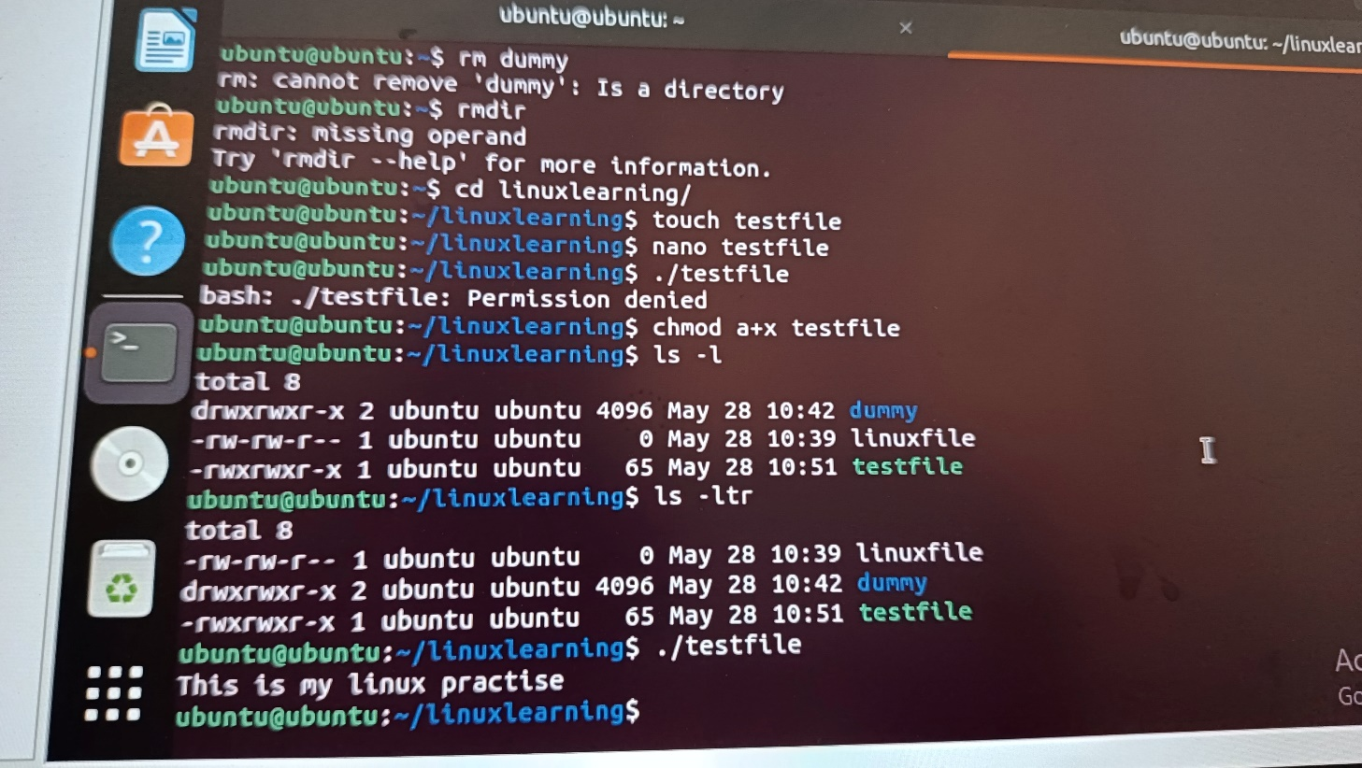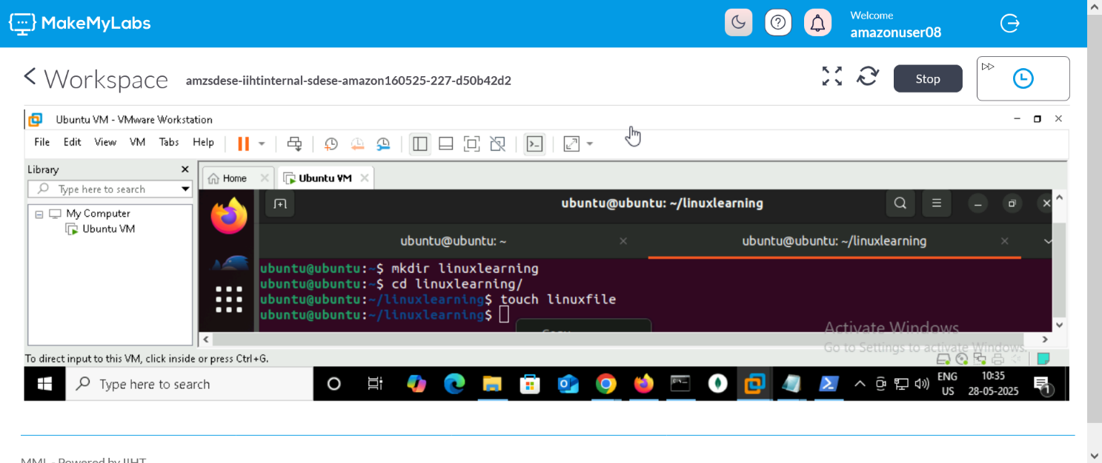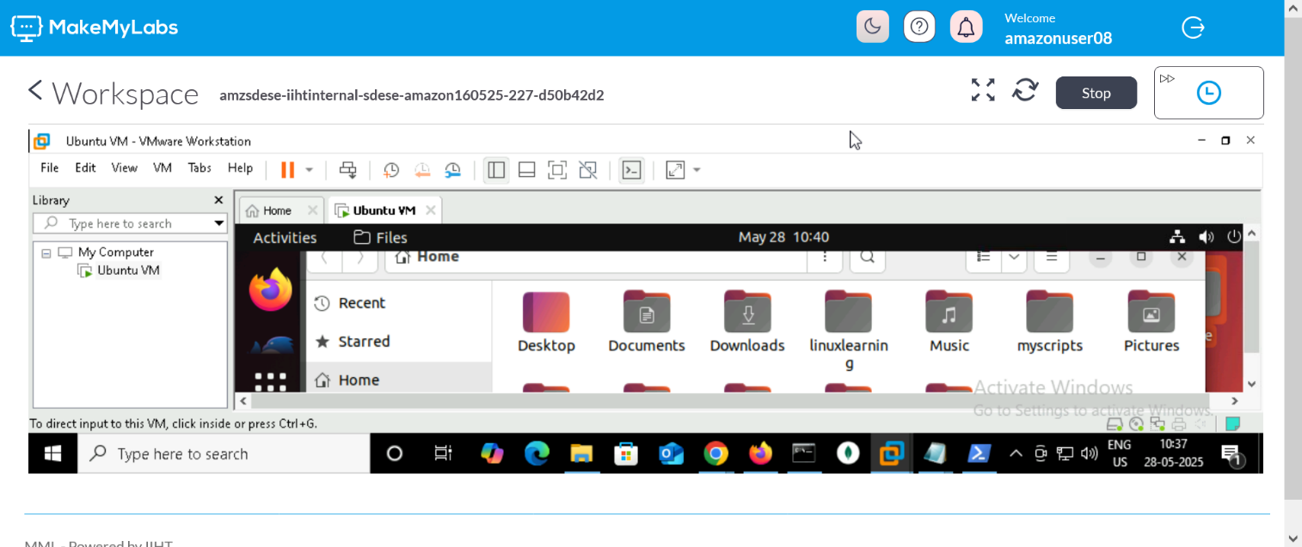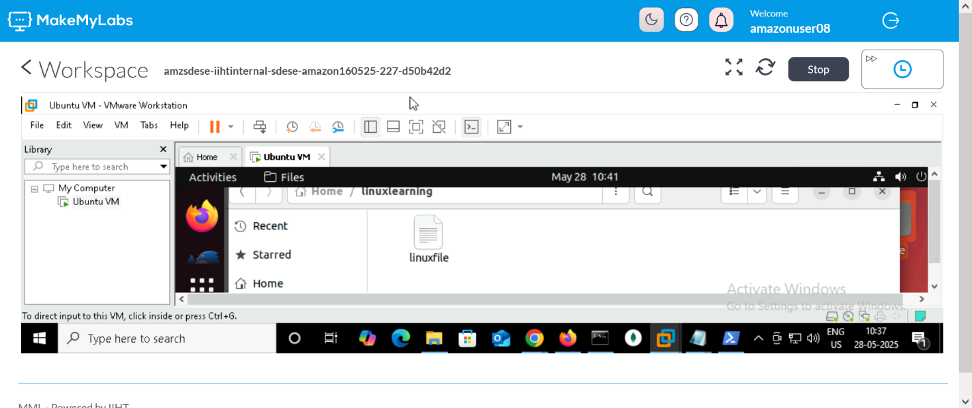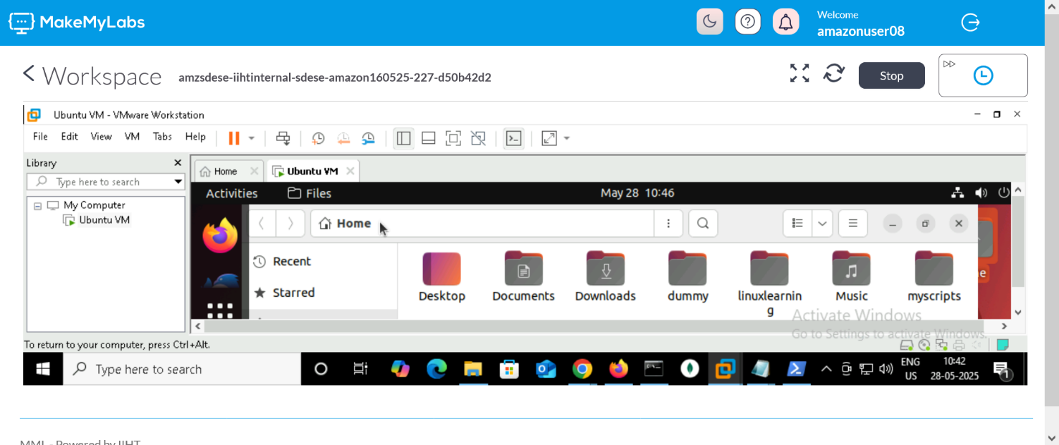

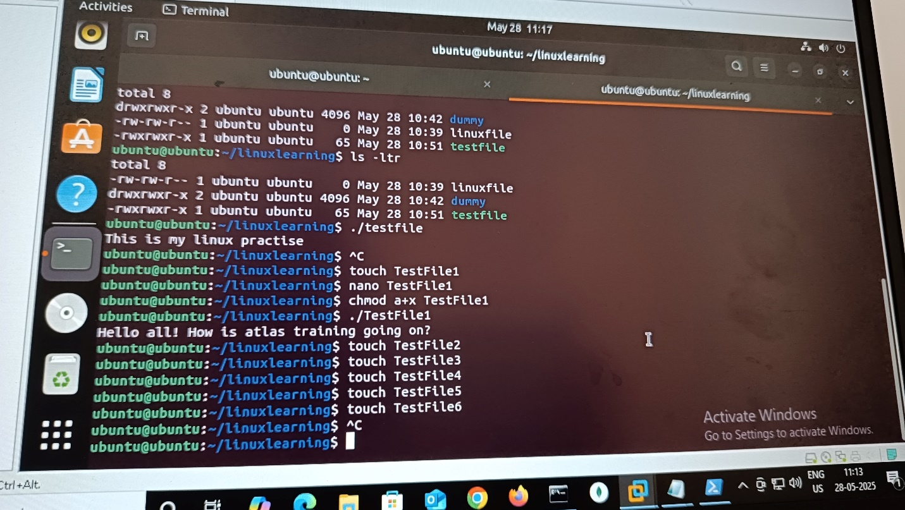

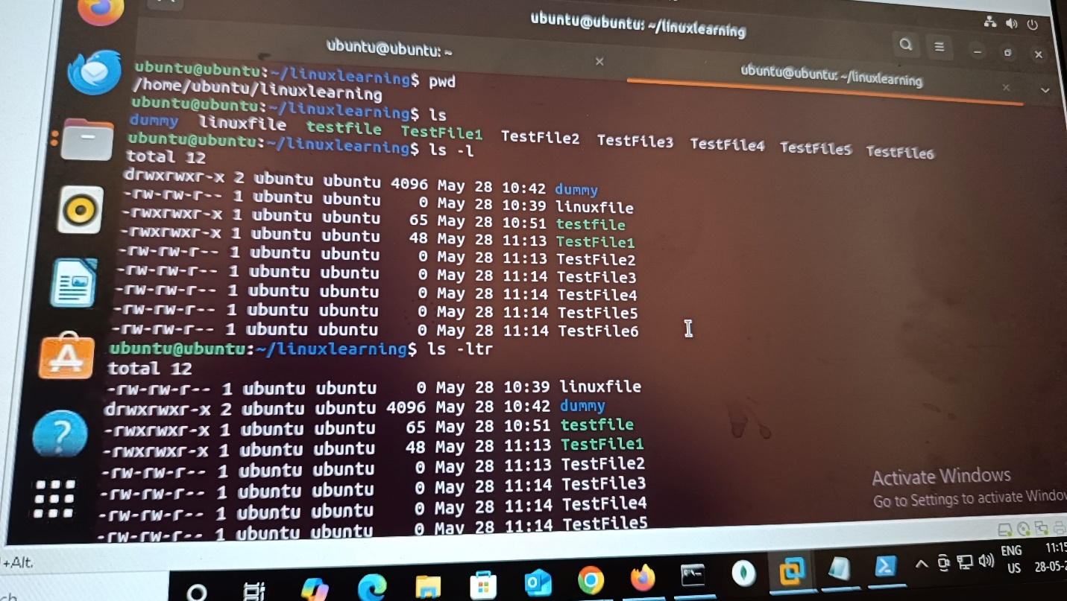

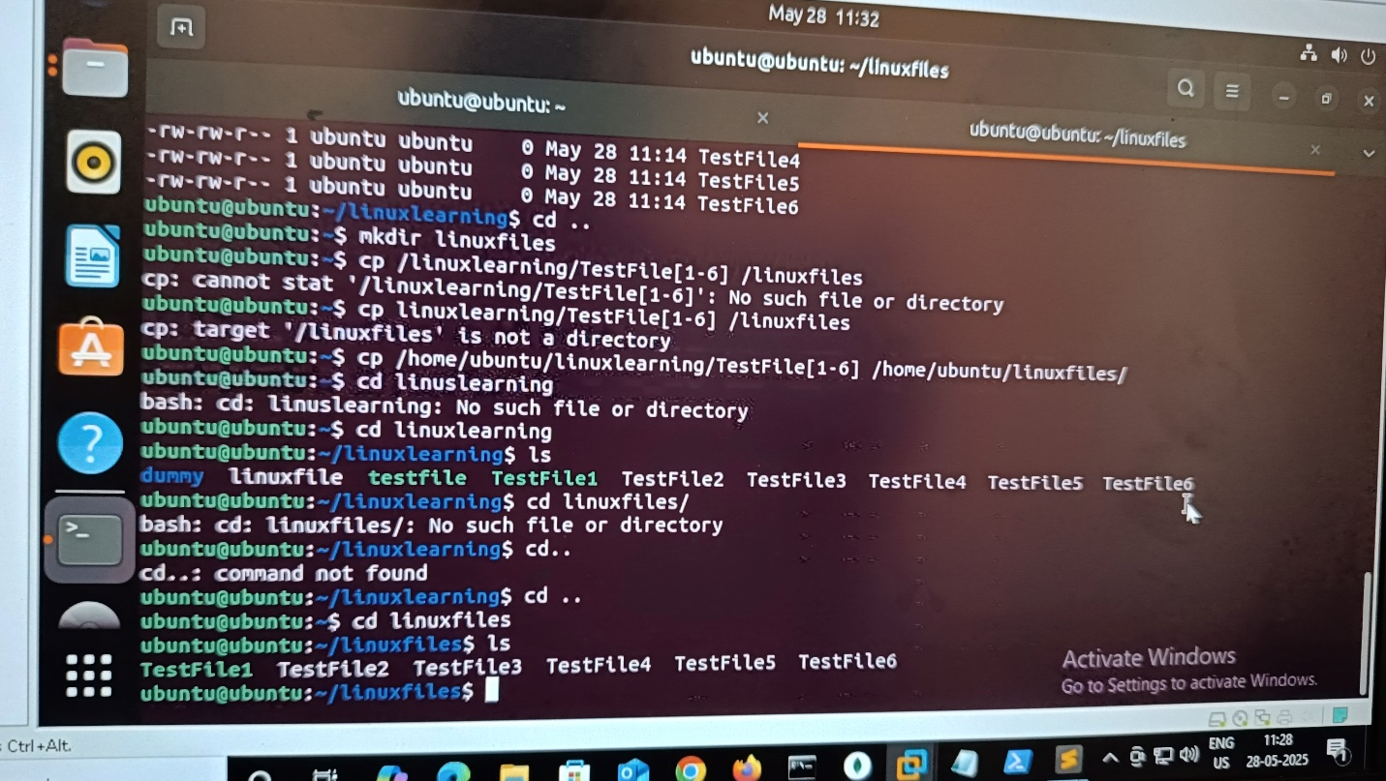

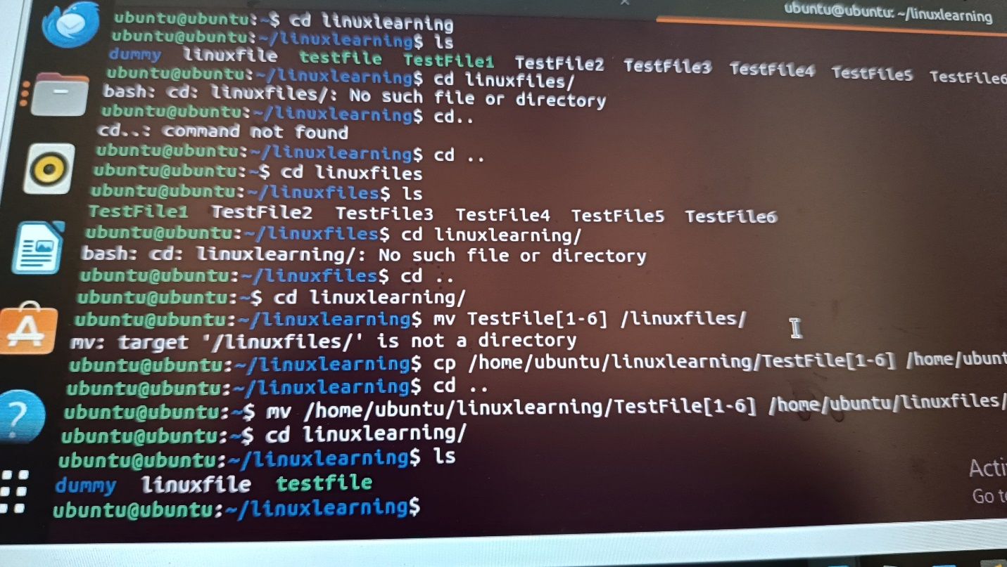

Removed directory dummy and file linuxfile:

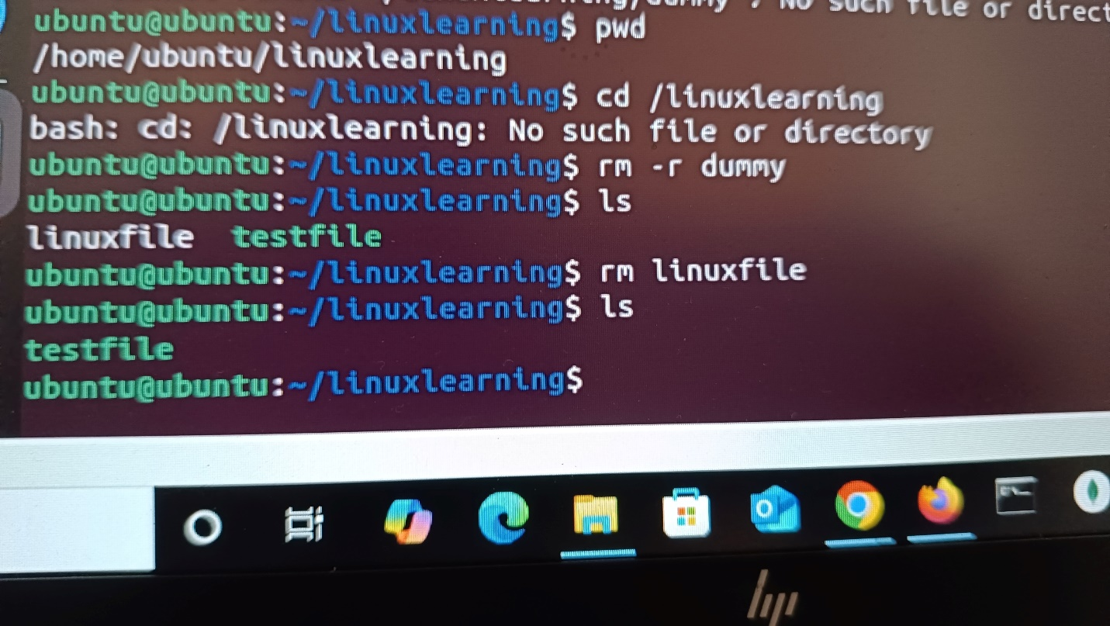

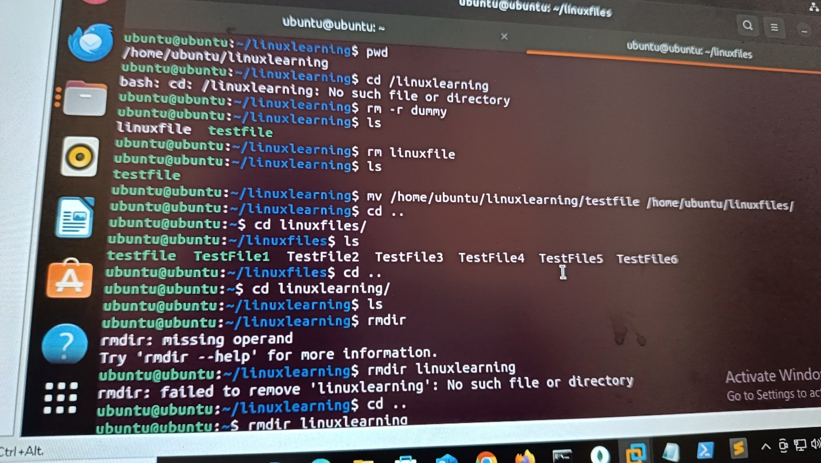

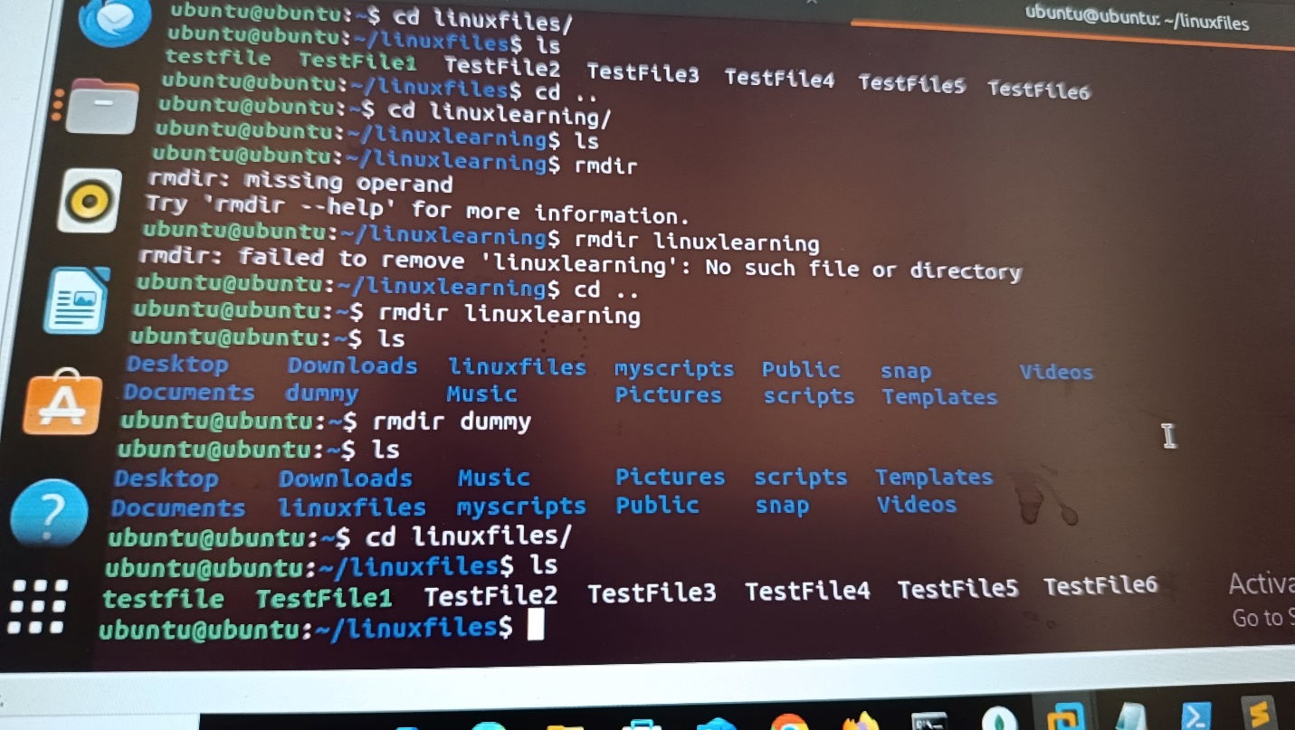

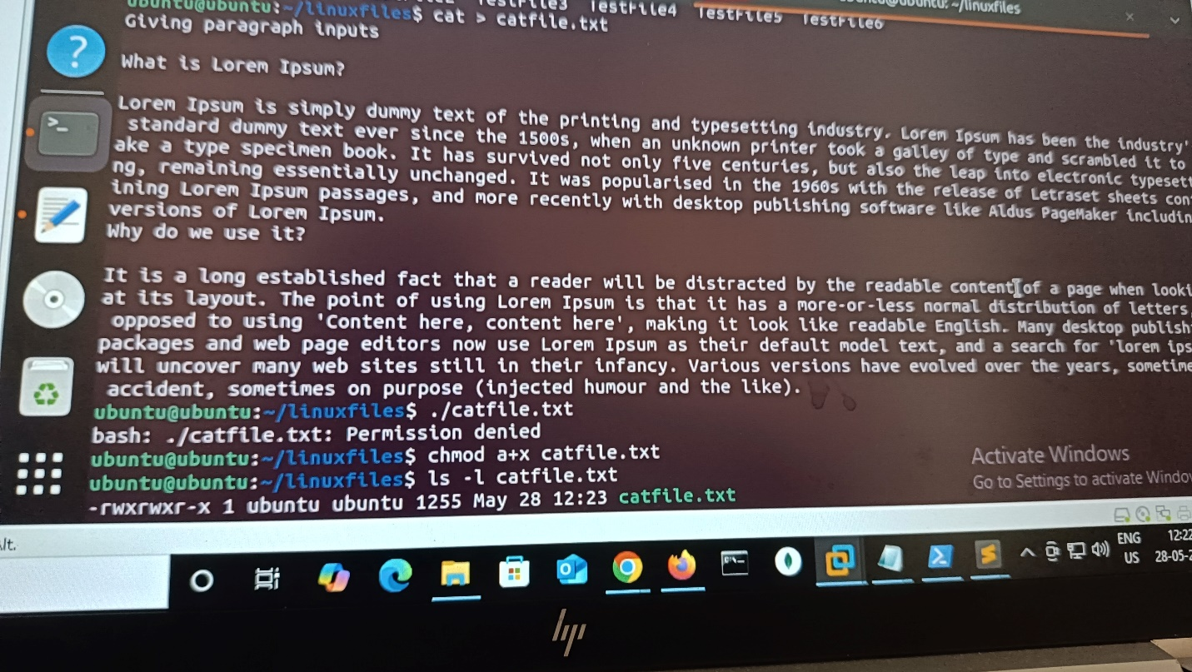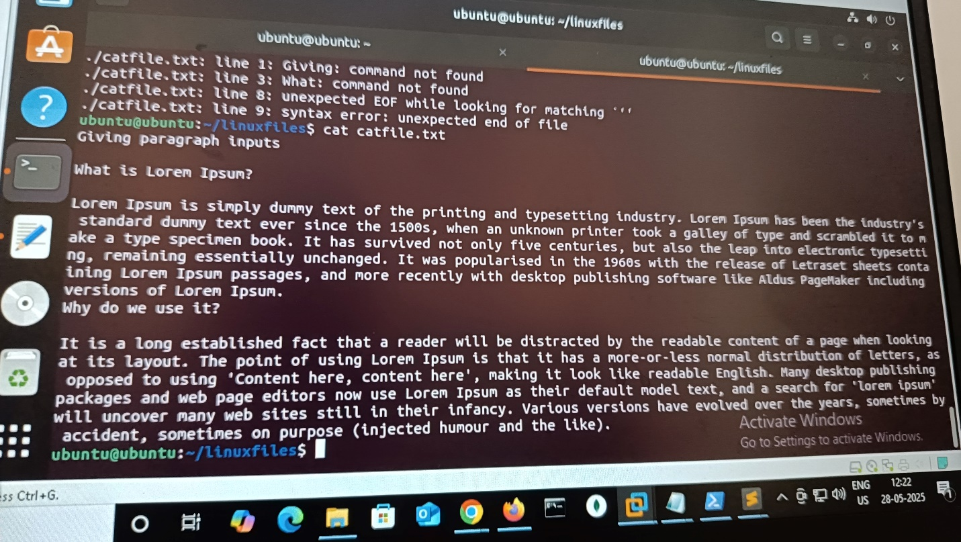

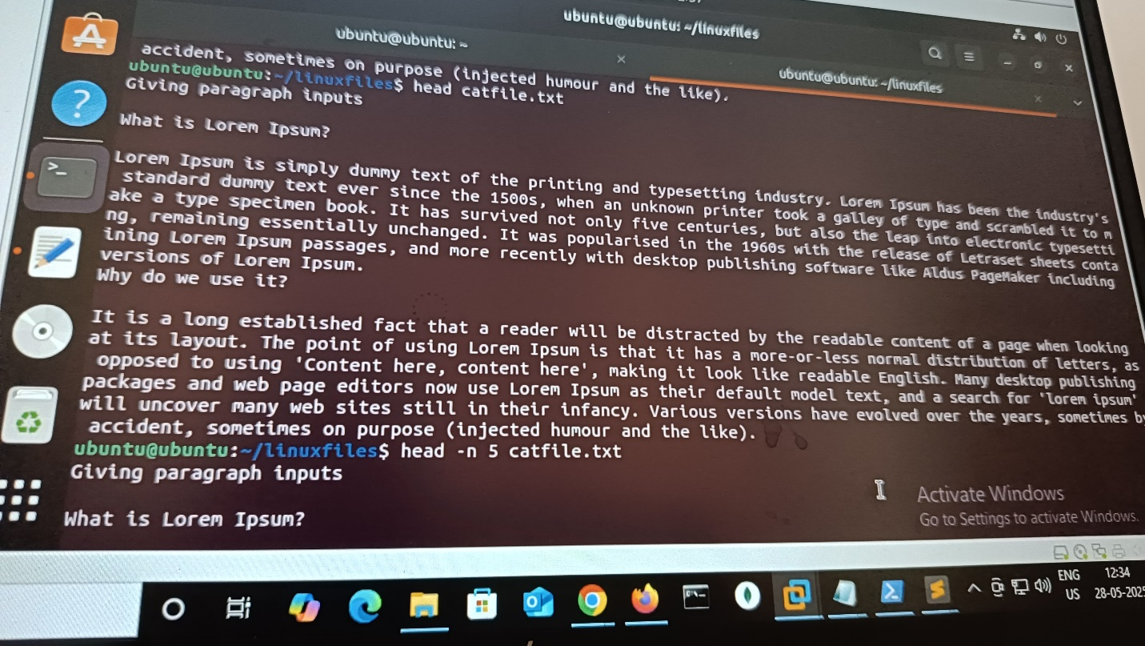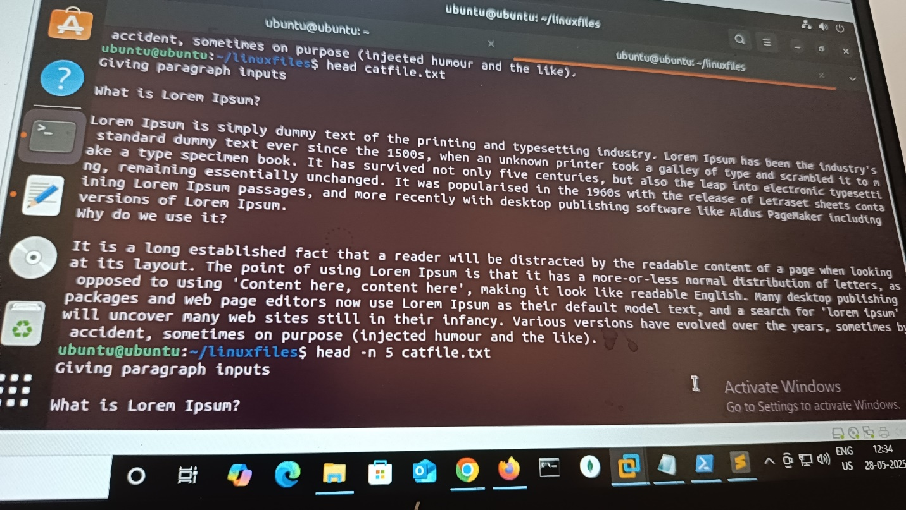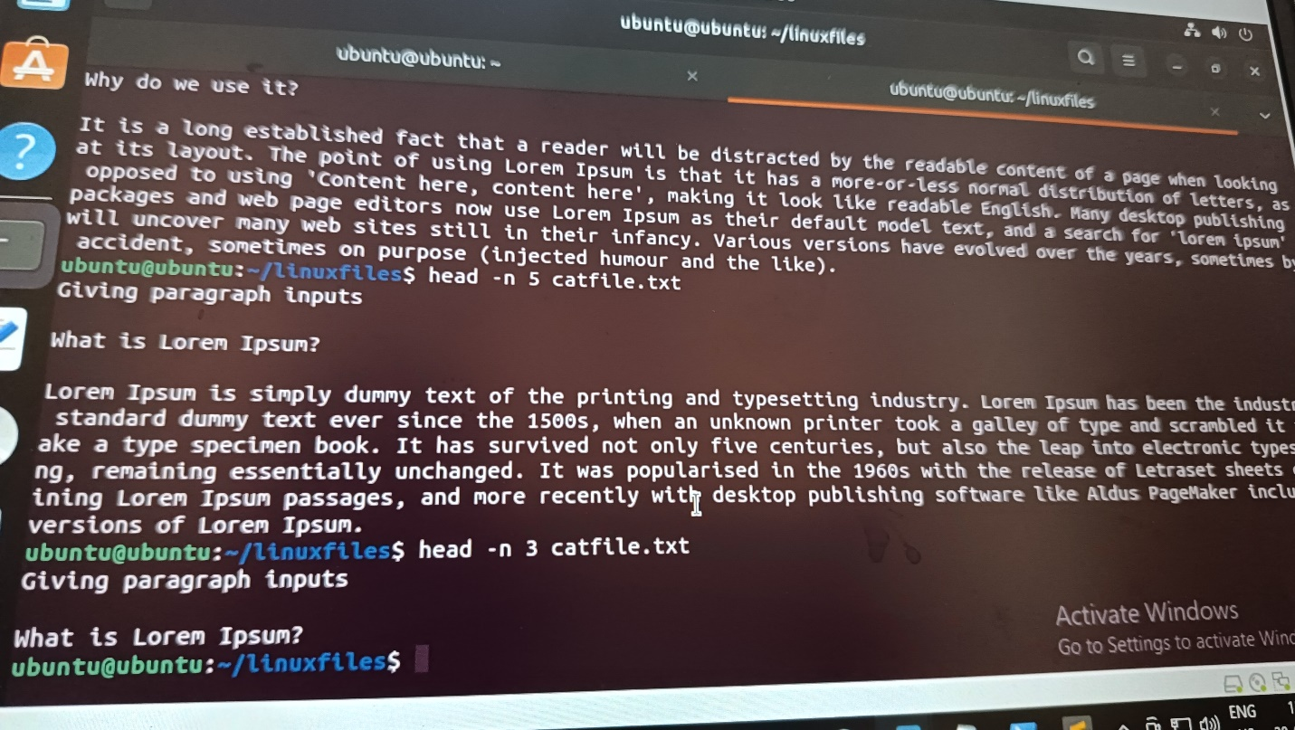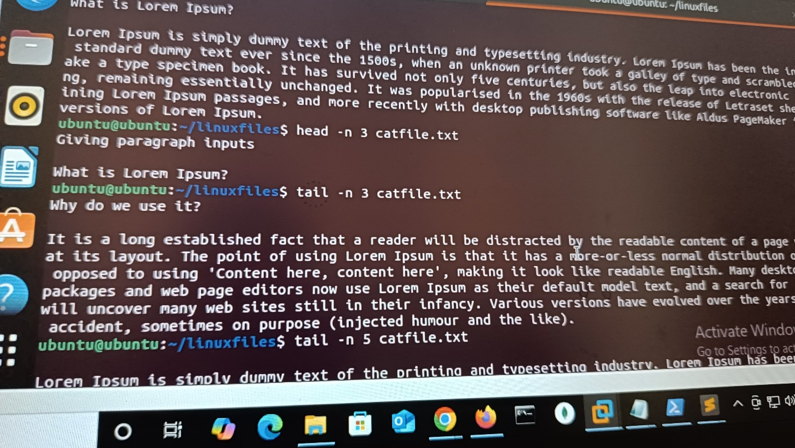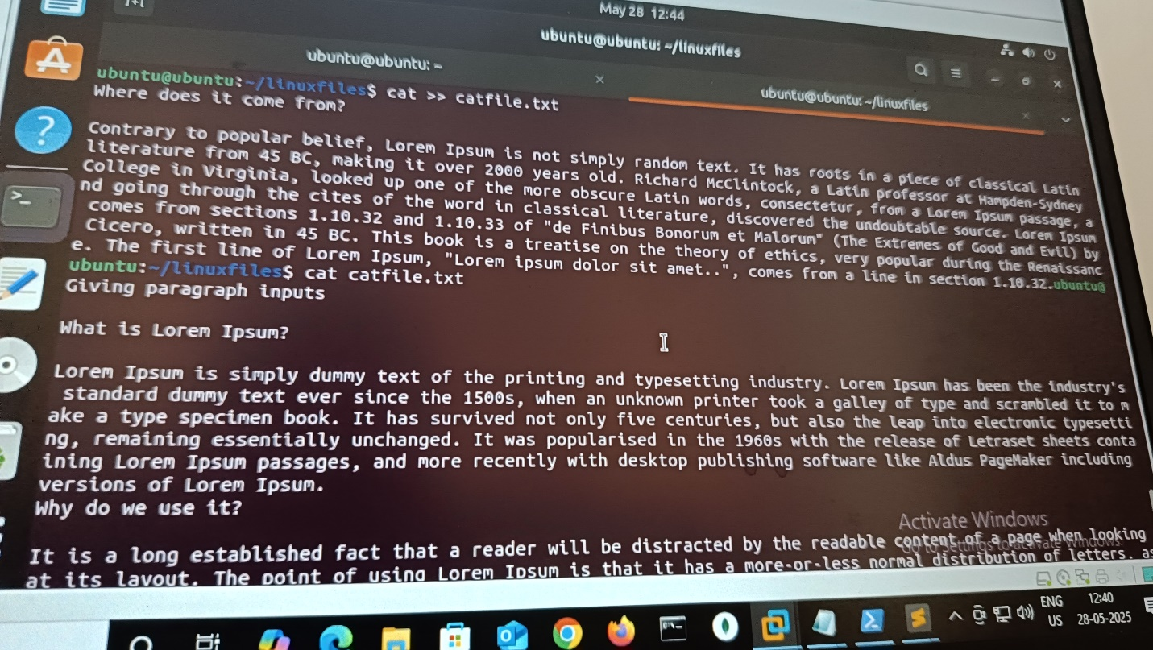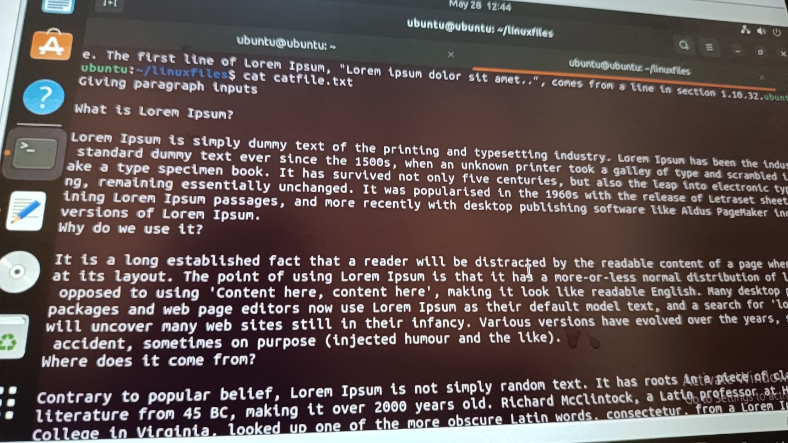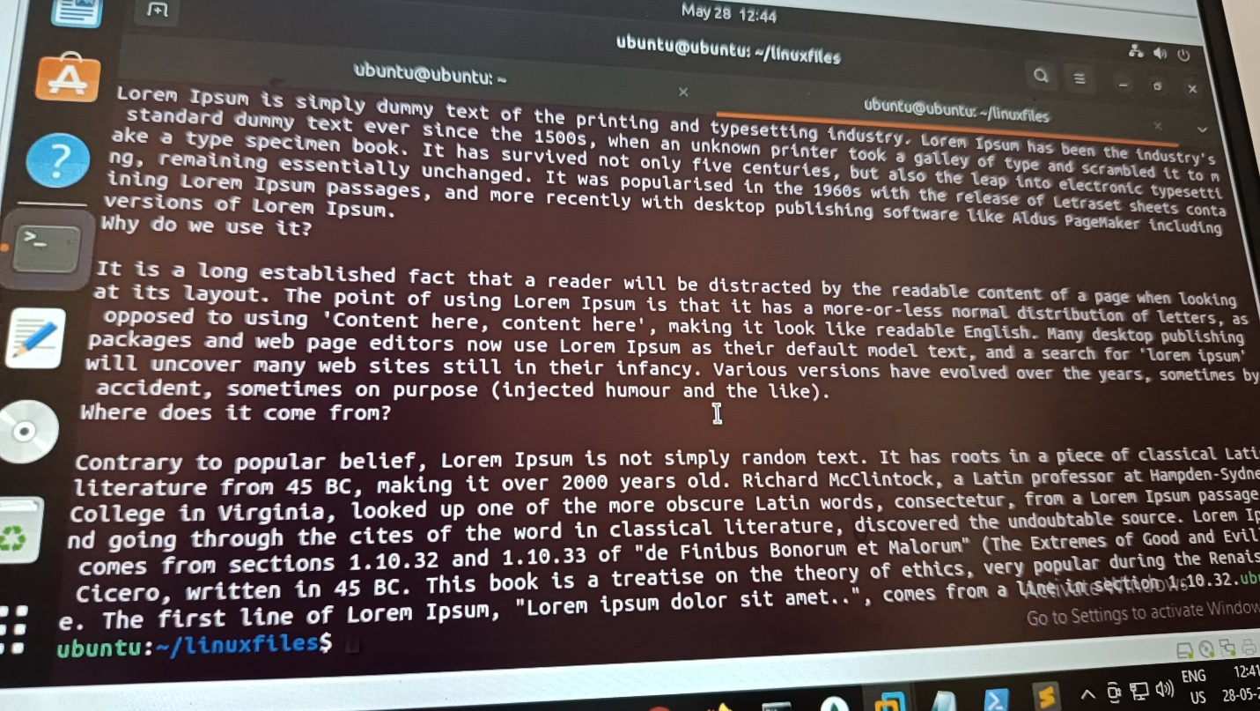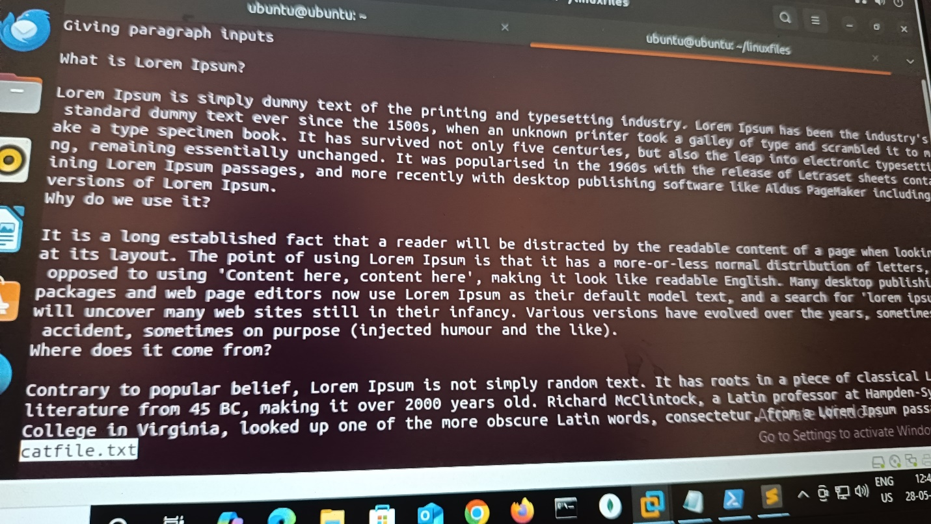

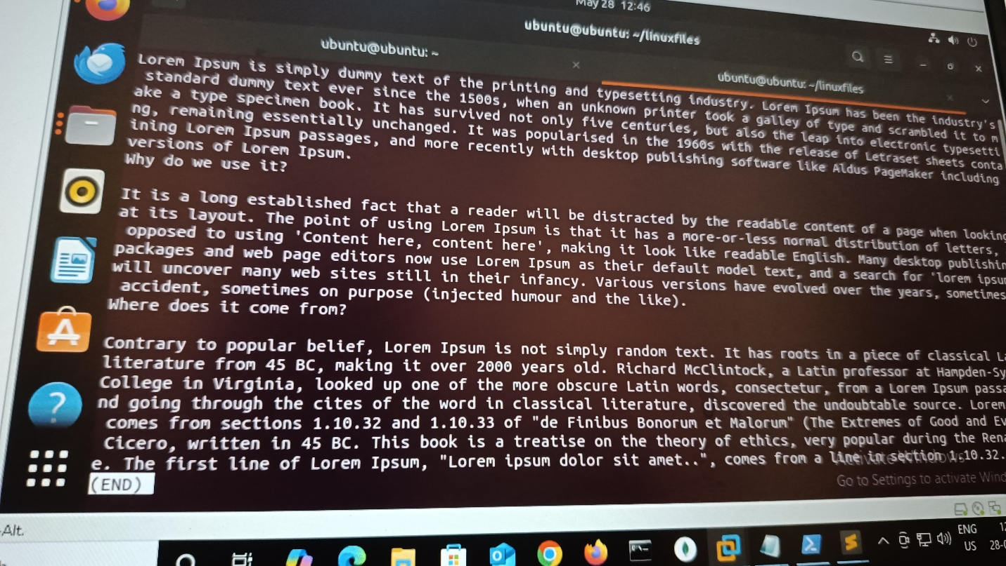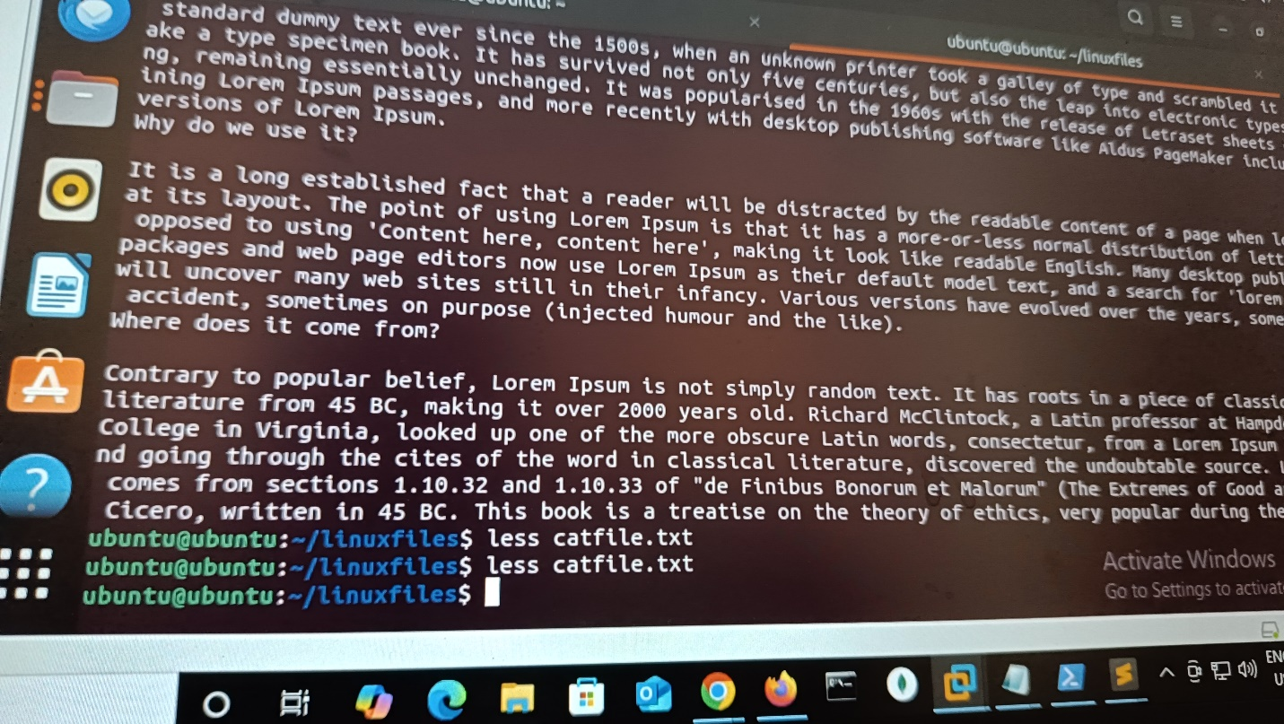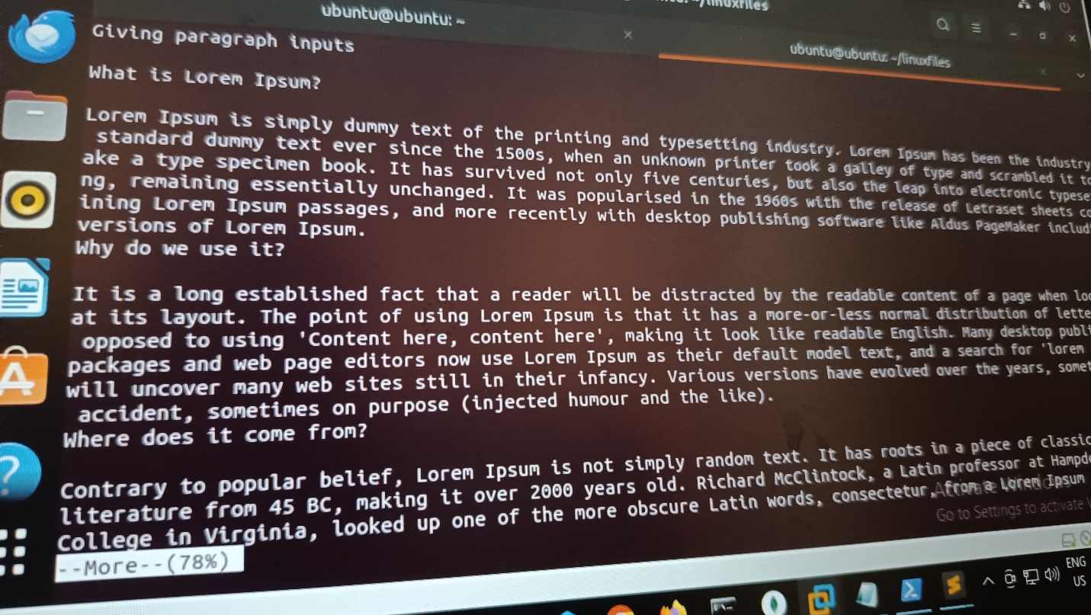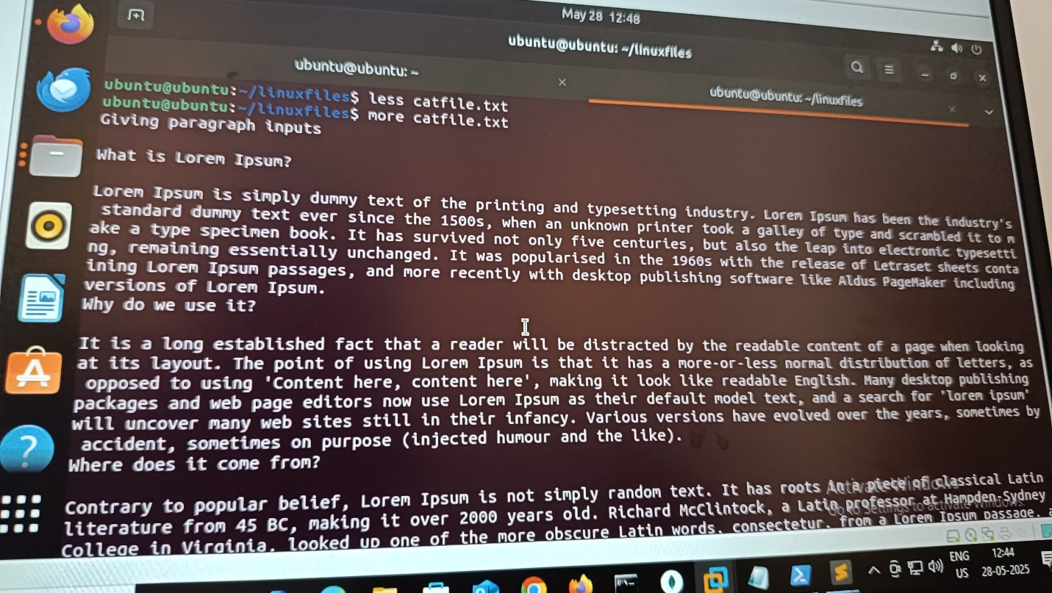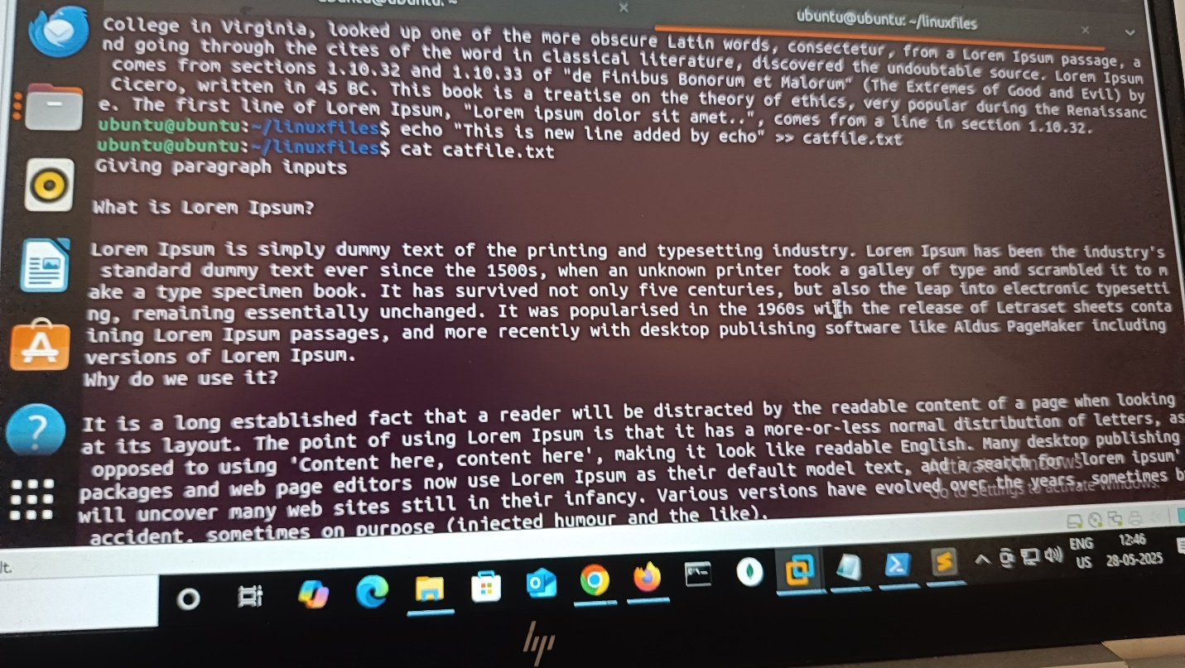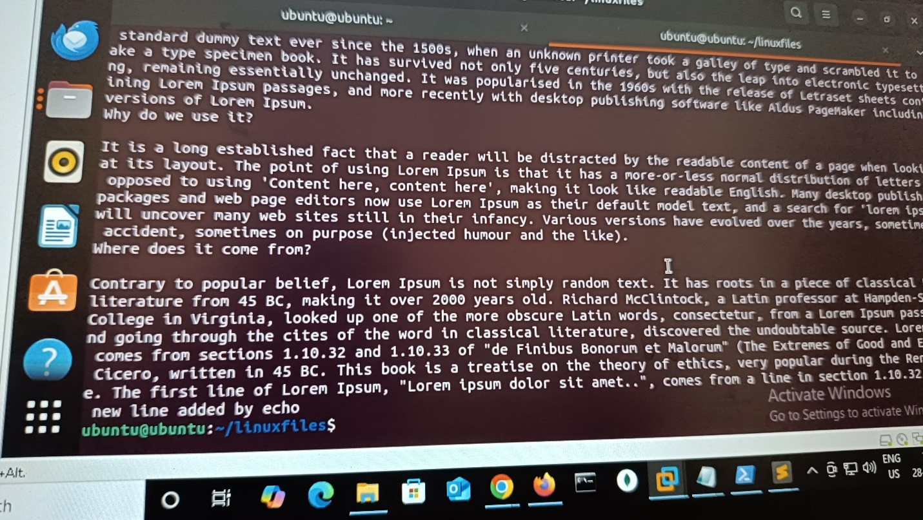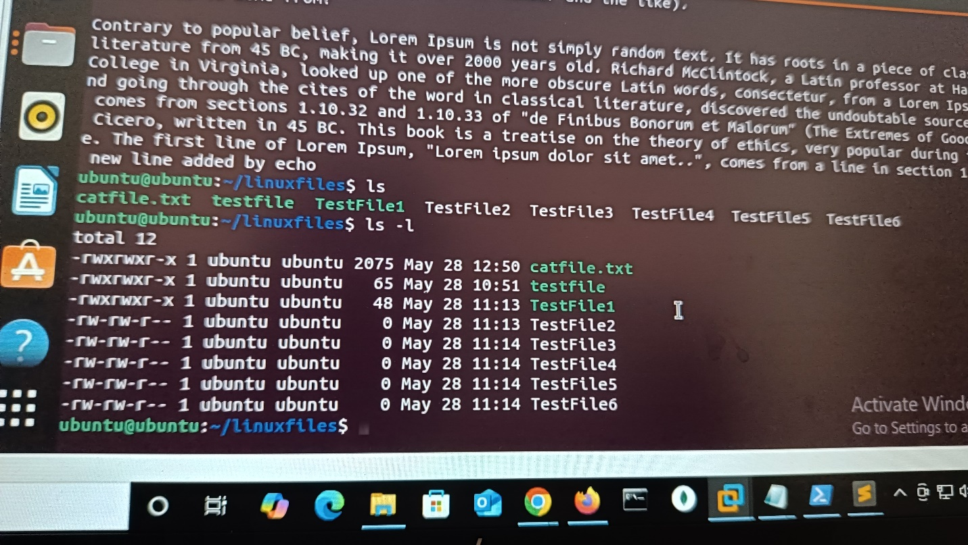

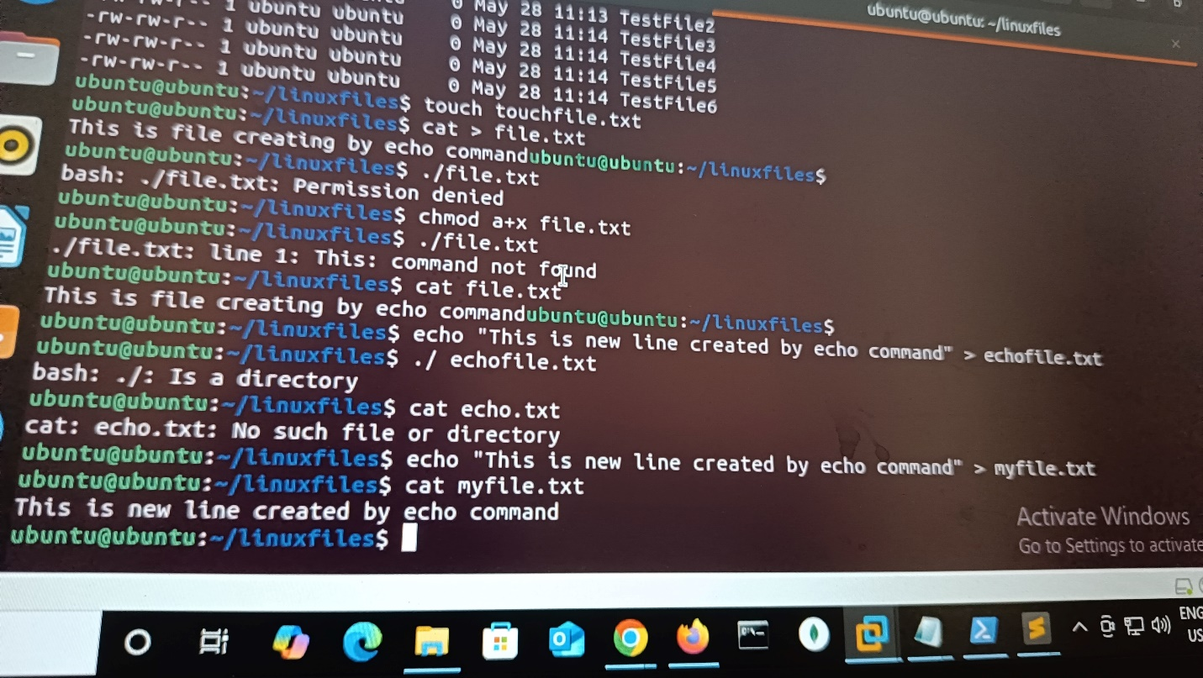

ubuntu@ubuntu:~/linuxfiles$ cat catfile.txt  
Giving paragraph inputs  
  
What is Lorem Ipsum?  
  
Lorem Ipsum is simply dummy text of the printing and typesetting industry. Lorem Ipsum has been the industry's standard dummy text ever since the 1500s, when an unknown printer took a galley of type and scrambled it to make a type specimen book. It has survived not only five centuries, but also the leap into electronic typesetting, remaining essentially unchanged. It was popularised in the 1960s with the release of Letraset sheets containing Lorem Ipsum passages, and more recently with desktop publishing software like Aldus PageMaker including versions of Lorem Ipsum.  
Why do we use it?  
  
It is a long established fact that a reader will be distracted by the readable content of a page when looking at its layout. The point of using Lorem Ipsum is that it has a more-or-less normal distribution of letters, as opposed to using 'Content here, content here', making it look like readable English. Many desktop publishing packages and web page editors now use Lorem Ipsum as their default model text, and a search for 'lorem ipsum' will uncover many web sites still in their infancy. Various versions have evolved over the years, sometimes by accident, sometimes on purpose (injected humour and the like).  
ubuntu@ubuntu:~/linuxfiles$ head catfile.txt  
Giving paragraph inputs  
  
What is Lorem Ipsum?  
  
Lorem Ipsum is simply dummy text of the printing and typesetting industry. Lorem Ipsum has been the industry's standard dummy text ever since the 1500s, when an unknown printer took a galley of type and scrambled it to make a type specimen book. It has survived not only five centuries, but also the leap into electronic typesetting, remaining essentially unchanged. It was popularised in the 1960s with the release of Letraset sheets containing Lorem Ipsum passages, and more recently with desktop publishing software like Aldus PageMaker including versions of Lorem Ipsum.  
Why do we use it?  
  
It is a long established fact that a reader will be distracted by the readable content of a page when looking at its layout. The point of using Lorem Ipsum is that it has a more-or-less normal distribution of letters, as opposed to using 'Content here, content here', making it look like readable English. Many desktop publishing packages and web page editors now use Lorem Ipsum as their default model text, and a search for 'lorem ipsum' will uncover many web sites still in their infancy. Various versions have evolved over the years, sometimes by accident, sometimes on purpose (injected humour and the like).  
ubuntu@ubuntu:~/linuxfiles$ head -n 5 catfile.txt  
Giving paragraph inputs  
  
What is Lorem Ipsum?  
  
Lorem Ipsum is simply dummy text of the printing and typesetting industry. Lorem Ipsum has been the industry's standard dummy text ever since the 1500s, when an unknown printer took a galley of type and scrambled it to make a type specimen book. It has survived not only five centuries, but also the leap into electronic typesetting, remaining essentially unchanged. It was popularised in the 1960s with the release of Letraset sheets containing Lorem Ipsum passages, and more recently with desktop publishing software like Aldus PageMaker including versions of Lorem Ipsum.  
ubuntu@ubuntu:~/linuxfiles$ head -n 3 catfile.txt  
Giving paragraph inputs  
  
What is Lorem Ipsum?  
ubuntu@ubuntu:~/linuxfiles$ tail -n 3 catfile.txt  
Why do we use it?  
  
It is a long established fact that a reader will be distracted by the readable content of a page when looking at its layout. The point of using Lorem Ipsum is that it has a more-or-less normal distribution of letters, as opposed to using 'Content here, content here', making it look like readable English. Many desktop publishing packages and web page editors now use Lorem Ipsum as their default model text, and a search for 'lorem ipsum' will uncover many web sites still in their infancy. Various versions have evolved over the years, sometimes by accident, sometimes on purpose (injected humour and the like).  
ubuntu@ubuntu:~/linuxfiles$ tail -n 5 catfile.txt  
  
Lorem Ipsum is simply dummy text of the printing and typesetting industry. Lorem Ipsum has been the industry's standard dummy text ever since the 1500s, when an unknown printer took a galley of type and scrambled it to make a type specimen book. It has survived not only five centuries, but also the leap into electronic typesetting, remaining essentially unchanged. It was popularised in the 1960s with the release of Letraset sheets containing Lorem Ipsum passages, and more recently with desktop publishing software like Aldus PageMaker including versions of Lorem Ipsum.  
Why do we use it?  
  
It is a long established fact that a reader will be distracted by the readable content of a page when looking at its layout. The point of using Lorem Ipsum is that it has a more-or-less normal distribution of letters, as opposed to using 'Content here, content here', making it look like readable English. Many desktop publishing packages and web page editors now use Lorem Ipsum as their default model text, and a search for 'lorem ipsum' will uncover many web sites still in their infancy. Various versions have evolved over the years, sometimes by accident, sometimes on purpose (injected humour and the like).  
ubuntu@ubuntu:~/linuxfiles$ cat >> catfile.txt  
Where does it come from?  
  
Contrary to popular belief, Lorem Ipsum is not simply random text. It has roots in a piece of classical Latin literature from 45 BC, making it over 2000 years old. Richard McClintock, a Latin professor at Hampden-Sydney College in Virginia, looked up one of the more obscure Latin words, consectetur, from a Lorem Ipsum passage, and going through the cites of the word in classical literature, discovered the undoubtable source. Lorem Ipsum comes from sections 1.10.32 and 1.10.33 of "de Finibus Bonorum et Malorum" (The Extremes of Good and Evil) by Cicero, written in 45 BC. This book is a treatise on the theory of ethics, very popular during the Renaissance. The first line of Lorem Ipsum, "Lorem ipsum dolor sit amet..", comes from a line in section [1.10.32.ubuntu@ubuntu:~/linuxfiles$](mailto:1.10.32.ubuntu@ubuntu:~/linuxfiles$) cat catfile.txt  
Giving paragraph inputs  
  
What is Lorem Ipsum?  
  
Lorem Ipsum is simply dummy text of the printing and typesetting industry. Lorem Ipsum has been the industry's standard dummy text ever since the 1500s, when an unknown printer took a galley of type and scrambled it to make a type specimen book. It has survived not only five centuries, but also the leap into electronic typesetting, remaining essentially unchanged. It was popularised in the 1960s with the release of Letraset sheets containing Lorem Ipsum passages, and more recently with desktop publishing software like Aldus PageMaker including versions of Lorem Ipsum.  
Why do we use it?  
  
It is a long established fact that a reader will be distracted by the readable content of a page when looking at its layout. The point of using Lorem Ipsum is that it has a more-or-less normal distribution of letters, as opposed to using 'Content here, content here', making it look like readable English. Many desktop publishing packages and web page editors now use Lorem Ipsum as their default model text, and a search for 'lorem ipsum' will uncover many web sites still in their infancy. Various versions have evolved over the years, sometimes by accident, sometimes on purpose (injected humour and the like).  
Where does it come from?  
  
Contrary to popular belief, Lorem Ipsum is not simply random text. It has roots in a piece of classical Latin literature from 45 BC, making it over 2000 years old. Richard McClintock, a Latin professor at Hampden-Sydney College in Virginia, looked up one of the more obscure Latin words, consectetur, from a Lorem Ipsum passage, and going through the cites of the word in classical literature, discovered the undoubtable source. Lorem Ipsum comes from sections 1.10.32 and 1.10.33 of "de Finibus Bonorum et Malorum" (The Extremes of Good and Evil) by Cicero, written in 45 BC. This book is a treatise on the theory of ethics, very popular during the Renaissancubuntu@ubuntu:~/linuxfiles$ less catfile.txt  
ubuntu@ubuntu:~/linuxfiles$ less catfile.txt  
ubuntu@ubuntu:~/linuxfiles$ more catfile.txt  
Giving paragraph inputs  
  
What is Lorem Ipsum?  
  
Lorem Ipsum is simply dummy text of the printing and typesetting industry. Lorem Ipsum has been the industry's  
 standard dummy text ever since the 1500s, when an unknown printer took a galley of type and scrambled it to m  
ake a type specimen book. It has survived not only five centuries, but also the leap into electronic typesetti  
ng, remaining essentially unchanged. It was popularised in the 1960s with the release of Letraset sheets conta  
ining Lorem Ipsum passages, and more recently with desktop publishing software like Aldus PageMaker including   
versions of Lorem Ipsum.  
Why do we use it?  
  
It is a long established fact that a reader will be distracted by the readable content of a page when looking   
at its layout. The point of using Lorem Ipsum is that it has a more-or-less normal distribution of letters, as  
 opposed to using 'Content here, content here', making it look like readable English. Many desktop publishing   
packages and web page editors now use Lorem Ipsum as their default model text, and a search for 'lorem ipsum'   
will uncover many web sites still in their infancy. Various versions have evolved over the years, sometimes by  
 accident, sometimes on purpose (injected humour and the like).  
Where does it come from?  
  
Contrary to popular belief, Lorem Ipsum is not simply random text. It has roots in a piece of classical Latin   
literature from 45 BC, making it over 2000 years old. Richard McClintock, a Latin professor at Hampden-Sydney   
College in Virginia, looked up one of the more obscure Latin words, consectetur, from a Lorem Ipsum passage, a  
nd going through the cites of the word in classical literature, discovered the undoubtable source. Lorem Ipsum  
 comes from sections 1.10.32 and 1.10.33 of "de Finibus Bonorum et Malorum" (The Extremes of Good and Evil) by  
 Cicero, written in 45 BC. This book is a treatise on the theory of ethics, very popular during the Renaissanc  
e. The first line of Lorem Ipsum, "Lorem ipsum dolor sit amet..", comes from a line in section 1.10.32.  
ubuntu@ubuntu:~/linuxfiles$ echo "This is new line added by echo" >> catfile.txt  
ubuntu@ubuntu:~/linuxfiles$ cat catfile.txt  
Giving paragraph inputs  
  
What is Lorem Ipsum?  
  
Lorem Ipsum is simply dummy text of the printing and typesetting industry. Lorem Ipsum has been the industry's standard dummy text ever since the 1500s, when an unknown printer took a galley of type and scrambled it to make a type specimen book. It has survived not only five centuries, but also the leap into electronic typesetting, remaining essentially unchanged. It was popularised in the 1960s with the release of Letraset sheets containing Lorem Ipsum passages, and more recently with desktop publishing software like Aldus PageMaker including versions of Lorem Ipsum.  
Why do we use it?  
  
It is a long established fact that a reader will be distracted by the readable content of a page when looking at its layout. The point of using Lorem Ipsum is that it has a more-or-less normal distribution of letters, as opposed to using 'Content here, content here', making it look like readable English. Many desktop publishing packages and web page editors now use Lorem Ipsum as their default model text, and a search for 'lorem ipsum' will uncover many web sites still in their infancy. Various versions have evolved over the years, sometimes by accident, sometimes on purpose (injected humour and the like).  
Where does it come from?  
  
Contrary to popular belief, Lorem Ipsum is not simply random text. It has roots in a piece of classical Latin literature from 45 BC, making it over 2000 years old. Richard McClintock, a Latin professor at Hampden-Sydney College in Virginia, looked up one of the more obscure Latin words, consectetur, from a Lorem Ipsum passage, and going through the cites of the word in classical literature, discovered the undoubtable source. Lorem Ipsum comes from sections 1.10.32 and 1.10.33 of "de Finibus Bonorum et Malorum" (The Extremes of Good and Evil) by Cicero, written in 45 BC. This book is a treatise on the theory of ethics, very popular during the Renaissance. The first line of Lorem Ipsum, "Lorem ipsum dolor sit amet..", comes from a line in section 1.10.32.This is new line added by echo  
ubuntu@ubuntu:~/linuxfiles$ ls  
catfile.txt  testfile  TestFile1  TestFile2  TestFile3  TestFile4  TestFile5  TestFile6  
ubuntu@ubuntu:~/linuxfiles$ ls -l  
total 12  
-rwxrwxr-x 1 ubuntu ubuntu 2075 May 28 12:50 catfile.txt  
-rwxrwxr-x 1 ubuntu ubuntu   65 May 28 10:51 testfile  
-rwxrwxr-x 1 ubuntu ubuntu   48 May 28 11:13 TestFile1  
-rw-rw-r-- 1 ubuntu ubuntu    0 May 28 11:13 TestFile2  
-rw-rw-r-- 1 ubuntu ubuntu    0 May 28 11:14 TestFile3  
-rw-rw-r-- 1 ubuntu ubuntu    0 May 28 11:14 TestFile4  
-rw-rw-r-- 1 ubuntu ubuntu    0 May 28 11:14 TestFile5  
-rw-rw-r-- 1 ubuntu ubuntu    0 May 28 11:14 TestFile6  
ubuntu@ubuntu:~/linuxfiles$ touch touchfile.txt  
ubuntu@ubuntu:~/linuxfiles$ cat > file.txt  
This is file creating by echo commandubuntu@ubuntu:~/linuxfiles$   
ubuntu@ubuntu:~/linuxfiles$ ./file.txt  
bash: ./file.txt: Permission denied  
ubuntu@ubuntu:~/linuxfiles$ chmod a+x file.txt  
ubuntu@ubuntu:~/linuxfiles$ ./file.txt  
./file.txt: line 1: This: command not found  
ubuntu@ubuntu:~/linuxfiles$ cat file.txt  
This is file creating by echo commandubuntu@ubuntu:~/linuxfiles$   
ubuntu@ubuntu:~/linuxfiles$ echo "This is new line created by echo command" > echofile.txt  
ubuntu@ubuntu:~/linuxfiles$ ./ echofile.txt  
bash: ./: Is a directory  
ubuntu@ubuntu:~/linuxfiles$ cat echo.txt  
cat: echo.txt: No such file or directory  
ubuntu@ubuntu:~/linuxfiles$ echo "This is new line created by echo command" > myfile.txt  
ubuntu@ubuntu:~/linuxfiles$ cat myfile.txt  
This is new line created by echo command  
ubuntu@ubuntu:~/linuxfiles$

**Write the difference between touch, cat and echo commands.**

**touch is used to create empty files or modify the timestamps of existing files. It does not modify the file's contents.**

**cat (concatenate) is used to display the content of one or more files to the terminal or to redirect the output to another file.**

**echo is used to print text to the standard output (usually the terminal), enabling the display of text, variables, or the results of commands.**

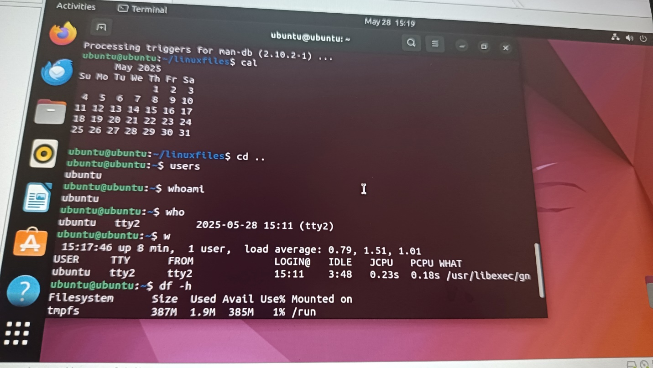

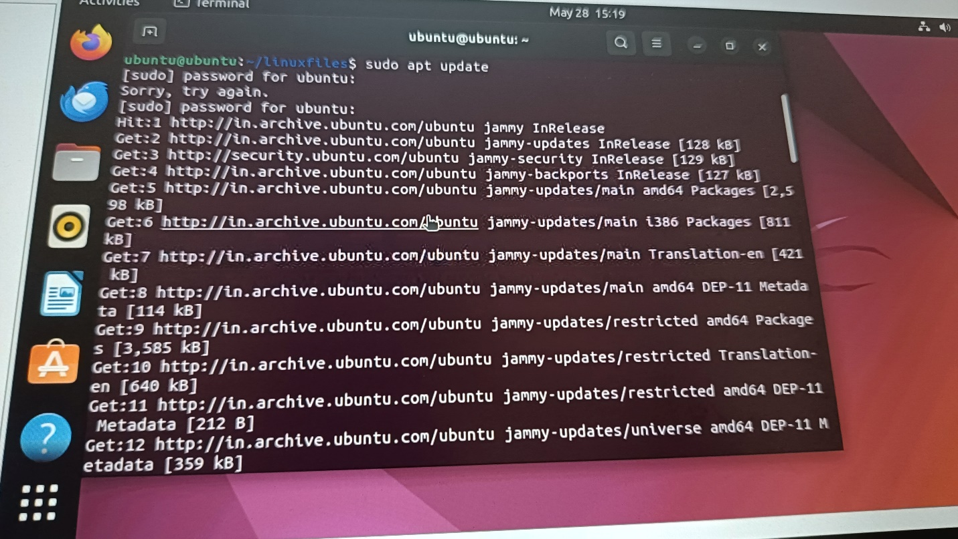

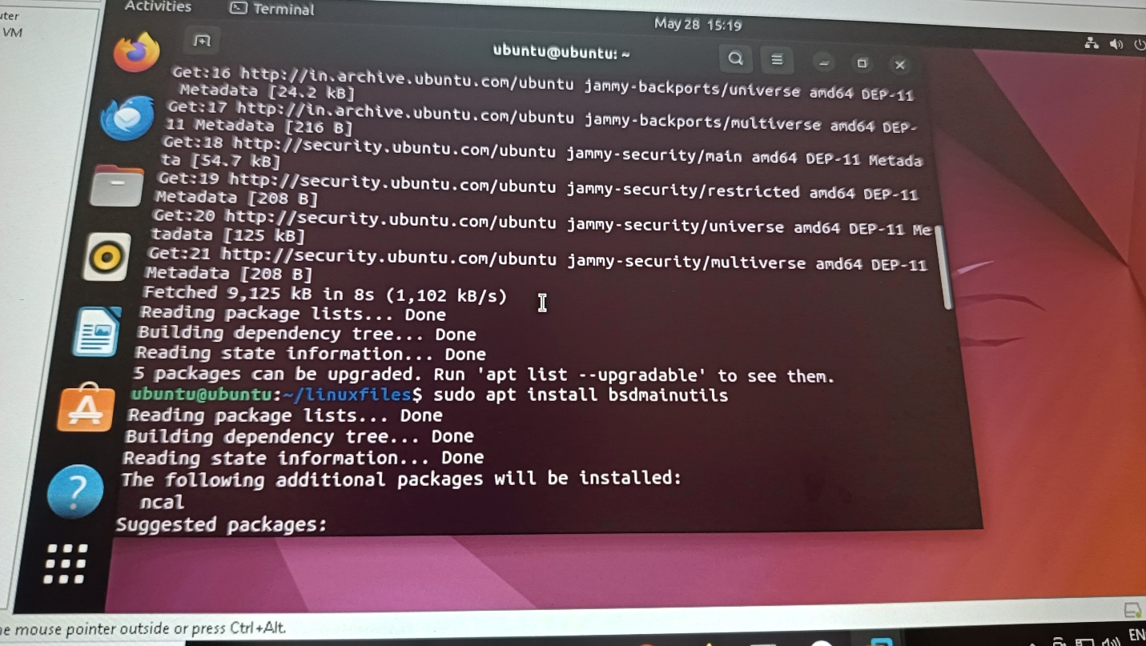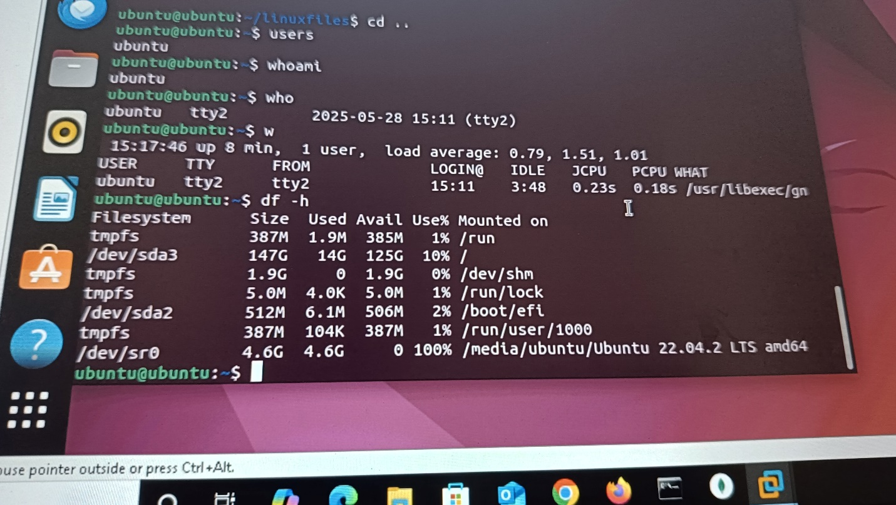

ubuntu@ubuntu:~$ ls  
Desktop    Downloads   Music      Pictures  scripts  Templates  
Documents  linuxfiles  myscripts  Public    snap     Videos  
ubuntu@ubuntu:~$ cd linuxfiles  
ubuntu@ubuntu:~/linuxfiles$ ./linuxfiles  
bash: ./linuxfiles: No such file or directory  
ubuntu@ubuntu:~/linuxfiles$ cal  
Command 'cal' not found, but can be installed with:  
sudo apt install ncal  
ubuntu@ubuntu:~/linuxfiles$ sudo apt update  
[sudo] password for ubuntu:   
Sorry, try again.  
[sudo] password for ubuntu:   
Hit:1 <http://in.archive.ubuntu.com/ubuntu> jammy InRelease  
Get:2 <http://in.archive.ubuntu.com/ubuntu> jammy-updates InRelease [128 kB]  
Get:3 <http://security.ubuntu.com/ubuntu> jammy-security InRelease [129 kB]  
Get:4 <http://in.archive.ubuntu.com/ubuntu> jammy-backports InRelease [127 kB]  
Get:5 <http://in.archive.ubuntu.com/ubuntu> jammy-updates/main amd64 Packages [2,598 kB]  
Get:6 <http://in.archive.ubuntu.com/ubuntu> jammy-updates/main i386 Packages [811 kB]  
Get:7 <http://in.archive.ubuntu.com/ubuntu> jammy-updates/main Translation-en [421 kB]  
Get:8 <http://in.archive.ubuntu.com/ubuntu> jammy-updates/main amd64 DEP-11 Metadata [114 kB]  
Get:9 <http://in.archive.ubuntu.com/ubuntu> jammy-updates/restricted amd64 Packages [3,585 kB]  
Get:10 <http://in.archive.ubuntu.com/ubuntu> jammy-updates/restricted Translation-en [640 kB]  
Get:11 <http://in.archive.ubuntu.com/ubuntu> jammy-updates/restricted amd64 DEP-11 Metadata [212 B]  
Get:12 <http://in.archive.ubuntu.com/ubuntu> jammy-updates/universe amd64 DEP-11 Metadata [359 kB]  
Get:13 <http://in.archive.ubuntu.com/ubuntu> jammy-updates/multiverse amd64 DEP-11 Metadata [940 B]  
Get:14 <http://in.archive.ubuntu.com/ubuntu> jammy-backports/main amd64 DEP-11 Metadata [7,088 B]  
Get:15 <http://in.archive.ubuntu.com/ubuntu> jammy-backports/restricted amd64 DEP-11 Metadata [216 B]  
Get:16 <http://in.archive.ubuntu.com/ubuntu> jammy-backports/universe amd64 DEP-11 Metadata [24.2 kB]  
Get:17 <http://in.archive.ubuntu.com/ubuntu> jammy-backports/multiverse amd64 DEP-11 Metadata [216 B]  
Get:18 <http://security.ubuntu.com/ubuntu> jammy-security/main amd64 DEP-11 Metadata [54.7 kB]  
Get:19 <http://security.ubuntu.com/ubuntu> jammy-security/restricted amd64 DEP-11 Metadata [208 B]  
Get:20 <http://security.ubuntu.com/ubuntu> jammy-security/universe amd64 DEP-11 Metadata [125 kB]  
Get:21 <http://security.ubuntu.com/ubuntu> jammy-security/multiverse amd64 DEP-11 Metadata [208 B]  
Fetched 9,125 kB in 8s (1,102 kB/s)                                              
Reading package lists... Done  
Building dependency tree... Done  
Reading state information... Done  
5 packages can be upgraded. Run 'apt list --upgradable' to see them.  
ubuntu@ubuntu:~/linuxfiles$ sudo apt install bsdmainutils  
Reading package lists... Done  
Building dependency tree... Done  
Reading state information... Done  
The following additional packages will be installed:  
  ncal  
Suggested packages:  
  calendar whois vacation mailutils  
The following NEW packages will be installed:  
  bsdmainutils ncal  
0 upgraded, 2 newly installed, 0 to remove and 5 not upgraded.  
Need to get 23.4 kB of archives.  
After this operation, 97.3 kB of additional disk space will be used.  
Do you want to continue? [Y/n] Y  
Get:1 <http://in.archive.ubuntu.com/ubuntu> jammy/universe amd64 ncal amd64 12.1.7+nmu3ubuntu2 [20.2 kB]  
Get:2 <http://in.archive.ubuntu.com/ubuntu> jammy/universe amd64 bsdmainutils all 12.1.7+nmu3ubuntu2 [3,170 B]  
Fetched 23.4 kB in 1s (23.4 kB/s)         
Selecting previously unselected package ncal.  
(Reading database ... 200379 files and directories currently installed.)  
Preparing to unpack .../ncal_12.1.7+nmu3ubuntu2_amd64.deb ...  
Unpacking ncal (12.1.7+nmu3ubuntu2) ...  
Selecting previously unselected package bsdmainutils.  
Preparing to unpack .../bsdmainutils_12.1.7+nmu3ubuntu2_all.deb ...  
Unpacking bsdmainutils (12.1.7+nmu3ubuntu2) ...  
Setting up ncal (12.1.7+nmu3ubuntu2) ...  
Setting up bsdmainutils (12.1.7+nmu3ubuntu2) ...  
Processing triggers for man-db (2.10.2-1) ...  
ubuntu@ubuntu:~/linuxfiles$ cal  
      May 2025          
Su Mo Tu We Th Fr Sa    
             1  2  3    
 4  5  6  7  8  9 10    
11 12 13 14 15 16 17    
18 19 20 21 22 23 24    
25 26 27 28 29 30 31    
                        
ubuntu@ubuntu:~/linuxfiles$ cd ..  
ubuntu@ubuntu:~$ users  
ubuntu  
ubuntu@ubuntu:~$ whoami  
ubuntu  
ubuntu@ubuntu:~$ who  
ubuntu   tty2         2025-05-28 15:11 (tty2)  
ubuntu@ubuntu:~$ w  
 15:17:46 up 8 min,  1 user,  load average: 0.79, 1.51, 1.01  
USER     TTY      FROM             LOGIN@   IDLE   JCPU   PCPU WHAT  
ubuntu   tty2     tty2             15:11    3:48   0.23s  0.18s /usr/libexec/gn  
ubuntu@ubuntu:~$ df -h  
Filesystem      Size  Used Avail Use% Mounted on  
tmpfs           387M  1.9M  385M   1% /run  
/dev/sda3       147G   14G  125G  10% /  
tmpfs           1.9G     0  1.9G   0% /dev/shm  
tmpfs           5.0M  4.0K  5.0M   1% /run/lock  
/dev/sda2       512M  6.1M  506M   2% /boot/efi  
tmpfs           387M  104K  387M   1% /run/user/1000  
/dev/sr0        4.6G  4.6G     0 100% /media/ubuntu/Ubuntu 22.04.2 LTS amd64  
ubuntu@ubuntu:~$

**task:**

**. single dot refers to the current directory, useful when want to execute or reference something within the current location.**

**.. double dot refers to the parent directory, allows us to go 1 level up.**

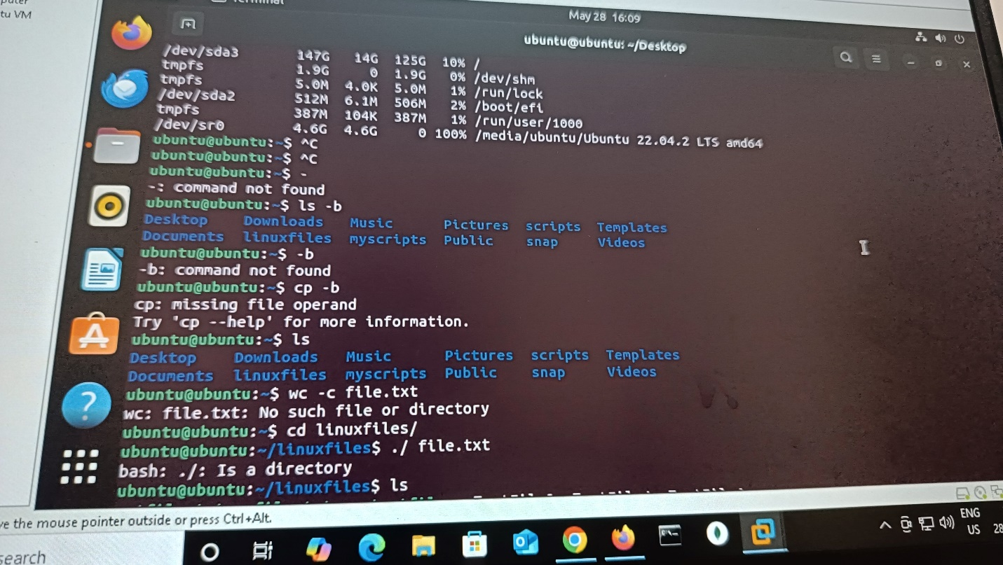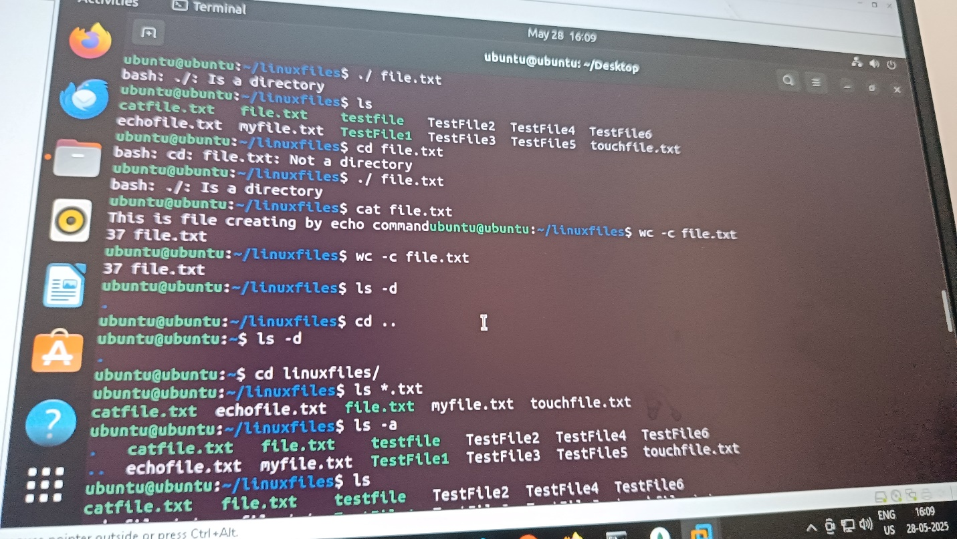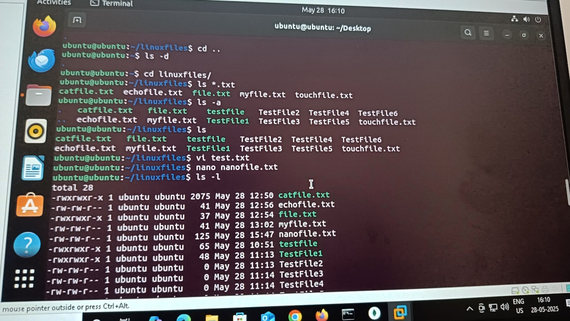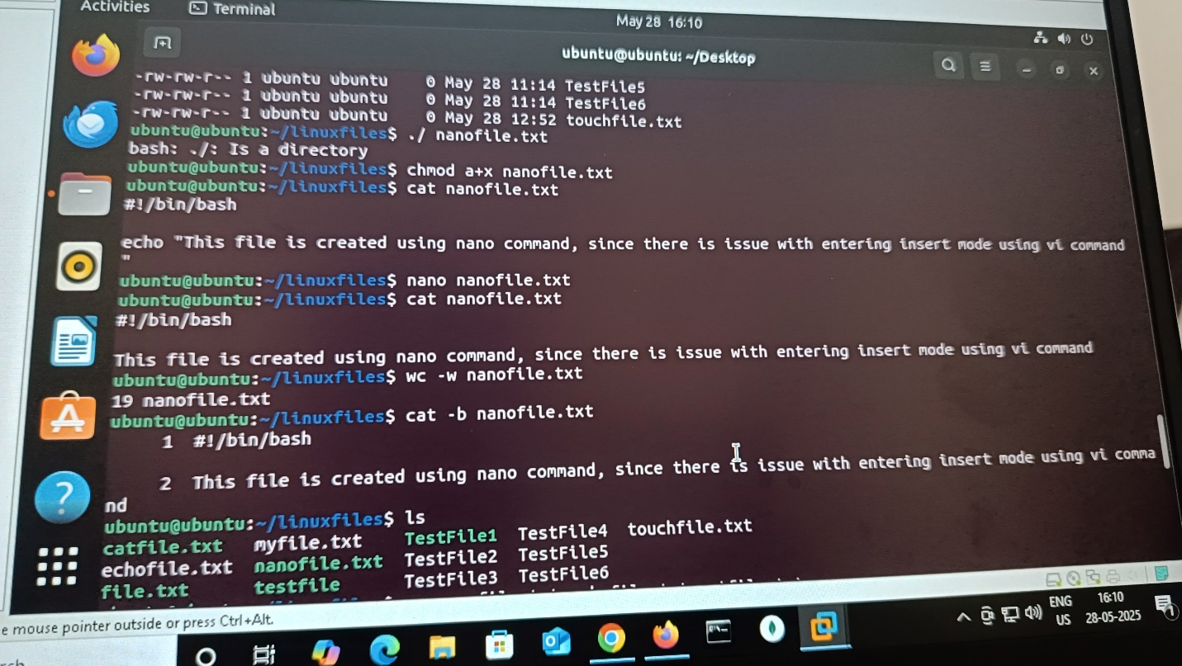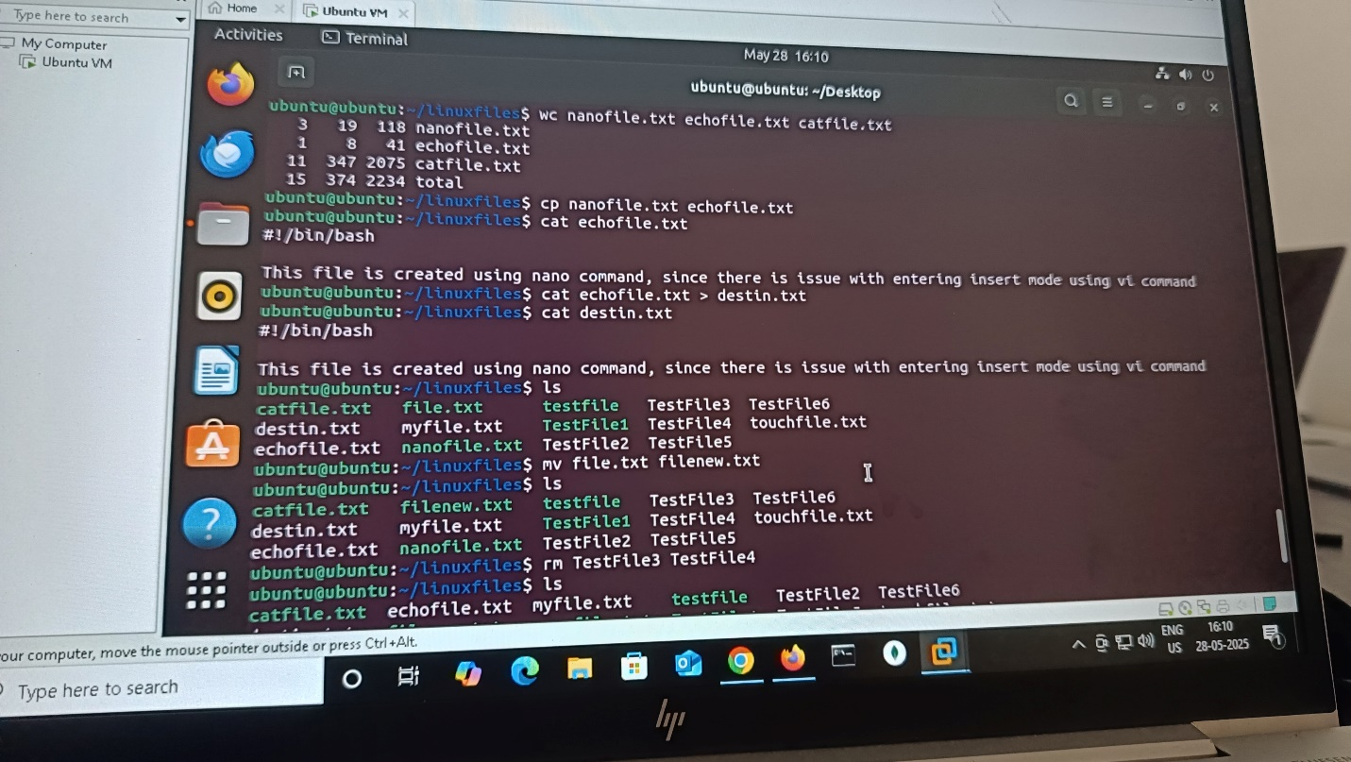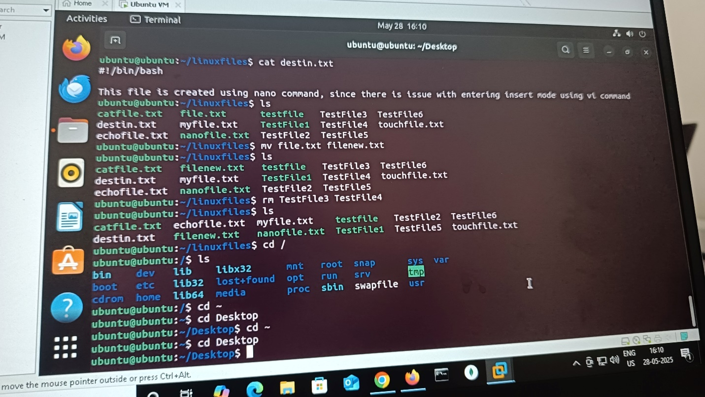

**ubuntu@ubuntu:~$ df -h**

**Filesystem Size Used Avail Use% Mounted on**

**tmpfs 387M 1.9M 385M 1% /run**

**/dev/sda3 147G 14G 125G 10% /**

**tmpfs 1.9G 0 1.9G 0% /dev/shm**

**tmpfs 5.0M 4.0K 5.0M 1% /run/lock**

**/dev/sda2 512M 6.1M 506M 2% /boot/efi**

**tmpfs 387M 104K 387M 1% /run/user/1000**

**/dev/sr0 4.6G 4.6G 0 100% /media/ubuntu/Ubuntu 22.04.2 LTS amd64**

**ubuntu@ubuntu:~$ ^C**

**ubuntu@ubuntu:~$ ^C**

**ubuntu@ubuntu:~$ -**

**-: command not found**

**ubuntu@ubuntu:~$ ls -b**

**Desktop Downloads Music Pictures scripts Templates**

**Documents linuxfiles myscripts Public snap Videos**

**ubuntu@ubuntu:~$ -b**

**-b: command not found**

**ubuntu@ubuntu:~$ cp -b**

**cp: missing file operand**

**Try 'cp --help' for more information.**

**ubuntu@ubuntu:~$ ls**

**Desktop Downloads Music Pictures scripts Templates**

**Documents linuxfiles myscripts Public snap Videos**

**ubuntu@ubuntu:~$ wc -c file.txt**

**wc: file.txt: No such file or directory**

**ubuntu@ubuntu:~$ cd linuxfiles/**

**ubuntu@ubuntu:~/linuxfiles$ ./ file.txt**

**bash: ./: Is a directory**

**ubuntu@ubuntu:~/linuxfiles$ ls**

**catfile.txt file.txt testfile TestFile2 TestFile4 TestFile6**

**echofile.txt myfile.txt TestFile1 TestFile3 TestFile5 touchfile.txt**

**ubuntu@ubuntu:~/linuxfiles$ cd file.txt**

**bash: cd: file.txt: Not a directory**

**ubuntu@ubuntu:~/linuxfiles$ ./ file.txt**

**bash: ./: Is a directory**

**ubuntu@ubuntu:~/linuxfiles$ cat file.txt**

**This is file creating by echo commandubuntu@ubuntu:~/linuxfiles$ wc -c file.txt**

**37 file.txt**

**ubuntu@ubuntu:~/linuxfiles$ wc -c file.txt**

**37 file.txt**

**ubuntu@ubuntu:~/linuxfiles$ ls -d**

**.**

**ubuntu@ubuntu:~/linuxfiles$ cd ..**

**ubuntu@ubuntu:~$ ls -d**

**.**

**ubuntu@ubuntu:~$ cd linuxfiles/**

**ubuntu@ubuntu:~/linuxfiles$ ls *.txt**

**catfile.txt echofile.txt file.txt myfile.txt touchfile.txt**

**ubuntu@ubuntu:~/linuxfiles$ ls -a**

**. catfile.txt file.txt testfile TestFile2 TestFile4 TestFile6**

**.. echofile.txt myfile.txt TestFile1 TestFile3 TestFile5 touchfile.txt**

**ubuntu@ubuntu:~/linuxfiles$ ls**

**catfile.txt file.txt testfile TestFile2 TestFile4 TestFile6**

**echofile.txt myfile.txt TestFile1 TestFile3 TestFile5 touchfile.txt**

**ubuntu@ubuntu:~/linuxfiles$ vi test.txt**

**ubuntu@ubuntu:~/linuxfiles$ nano nanofile.txt**

**ubuntu@ubuntu:~/linuxfiles$ ls -l**

**total 28**

**-rwxrwxr-x 1 ubuntu ubuntu 2075 May 28 12:50 catfile.txt**

**-rw-rw-r-- 1 ubuntu ubuntu 41 May 28 12:56 echofile.txt**

**-rwxrwxr-x 1 ubuntu ubuntu 37 May 28 12:54 file.txt**

**-rw-rw-r-- 1 ubuntu ubuntu 41 May 28 13:02 myfile.txt**

**-rw-rw-r-- 1 ubuntu ubuntu 125 May 28 15:47 nanofile.txt**

**-rwxrwxr-x 1 ubuntu ubuntu 65 May 28 10:51 testfile**

**-rwxrwxr-x 1 ubuntu ubuntu 48 May 28 11:13 TestFile1**

**-rw-rw-r-- 1 ubuntu ubuntu 0 May 28 11:13 TestFile2**

**-rw-rw-r-- 1 ubuntu ubuntu 0 May 28 11:14 TestFile3**

**-rw-rw-r-- 1 ubuntu ubuntu 0 May 28 11:14 TestFile4**

**-rw-rw-r-- 1 ubuntu ubuntu 0 May 28 11:14 TestFile5**

**-rw-rw-r-- 1 ubuntu ubuntu 0 May 28 11:14 TestFile6**

**-rw-rw-r-- 1 ubuntu ubuntu 0 May 28 12:52 touchfile.txt**

**ubuntu@ubuntu:~/linuxfiles$ ./ nanofile.txt**

**bash: ./: Is a directory**

**ubuntu@ubuntu:~/linuxfiles$ chmod a+x nanofile.txt**

**ubuntu@ubuntu:~/linuxfiles$ cat nanofile.txt**

**#!/bin/bash**

**echo "This file is created using nano command, since there is issue with entering insert mode using vi command"**

**ubuntu@ubuntu:~/linuxfiles$ nano nanofile.txt**

**ubuntu@ubuntu:~/linuxfiles$ cat nanofile.txt**

**#!/bin/bash**

**This file is created using nano command, since there is issue with entering insert mode using vi command**

**ubuntu@ubuntu:~/linuxfiles$ wc -w nanofile.txt**

**19 nanofile.txt**

**ubuntu@ubuntu:~/linuxfiles$ cat -b nanofile.txt**

**1 #!/bin/bash**

**2 This file is created using nano command, since there is issue with entering insert mode using vi command**

**ubuntu@ubuntu:~/linuxfiles$ ls**

**catfile.txt myfile.txt TestFile1 TestFile4 touchfile.txt**

**echofile.txt nanofile.txt TestFile2 TestFile5**

**file.txt testfile TestFile3 TestFile6**

**ubuntu@ubuntu:~/linuxfiles$ wc nanofile.txt echofile.txt catfile.txt**

**3 19 118 nanofile.txt**

**1 8 41 echofile.txt**

**11 347 2075 catfile.txt**

**15 374 2234 total**

**ubuntu@ubuntu:~/linuxfiles$ cp nanofile.txt echofile.txt**

**ubuntu@ubuntu:~/linuxfiles$ cat echofile.txt**

**#!/bin/bash**

**This file is created using nano command, since there is issue with entering insert mode using vi command**

**ubuntu@ubuntu:~/linuxfiles$ cat echofile.txt > destin.txt**

**ubuntu@ubuntu:~/linuxfiles$ cat destin.txt**

**#!/bin/bash**

**This file is created using nano command, since there is issue with entering insert mode using vi command**

**ubuntu@ubuntu:~/linuxfiles$ ls**

**catfile.txt file.txt testfile TestFile3 TestFile6**

**destin.txt myfile.txt TestFile1 TestFile4 touchfile.txt**

**echofile.txt nanofile.txt TestFile2 TestFile5**

**ubuntu@ubuntu:~/linuxfiles$ mv file.txt filenew.txt**

**ubuntu@ubuntu:~/linuxfiles$ ls**

**catfile.txt filenew.txt testfile TestFile3 TestFile6**

**destin.txt myfile.txt TestFile1 TestFile4 touchfile.txt**

**echofile.txt nanofile.txt TestFile2 TestFile5**

**ubuntu@ubuntu:~/linuxfiles$ rm TestFile3 TestFile4**

**ubuntu@ubuntu:~/linuxfiles$ ls**

**catfile.txt echofile.txt myfile.txt testfile TestFile2 TestFile6**

**destin.txt filenew.txt nanofile.txt TestFile1 TestFile5 touchfile.txt**

**ubuntu@ubuntu:~/linuxfiles$ cd /**

**ubuntu@ubuntu:/$ ls**

**bin dev lib libx32 mnt root snap sys var**

**boot etc lib32 lost+found opt run srv tmp**

**cdrom home lib64 media proc sbin swapfile usr**

**ubuntu@ubuntu:/$ cd ~**

**ubuntu@ubuntu:~$ cd Desktop**

**ubuntu@ubuntu:~/Desktop$ cd ~**

**ubuntu@ubuntu:~$ cd Desktop**

**ubuntu@ubuntu:~/Desktop$**